Reference : TQ48SW939

Name : E LONDON RVR CROSSING BH182

Year : null

Eastings: 543970 Northings: 181290

Sheet 1 of 4

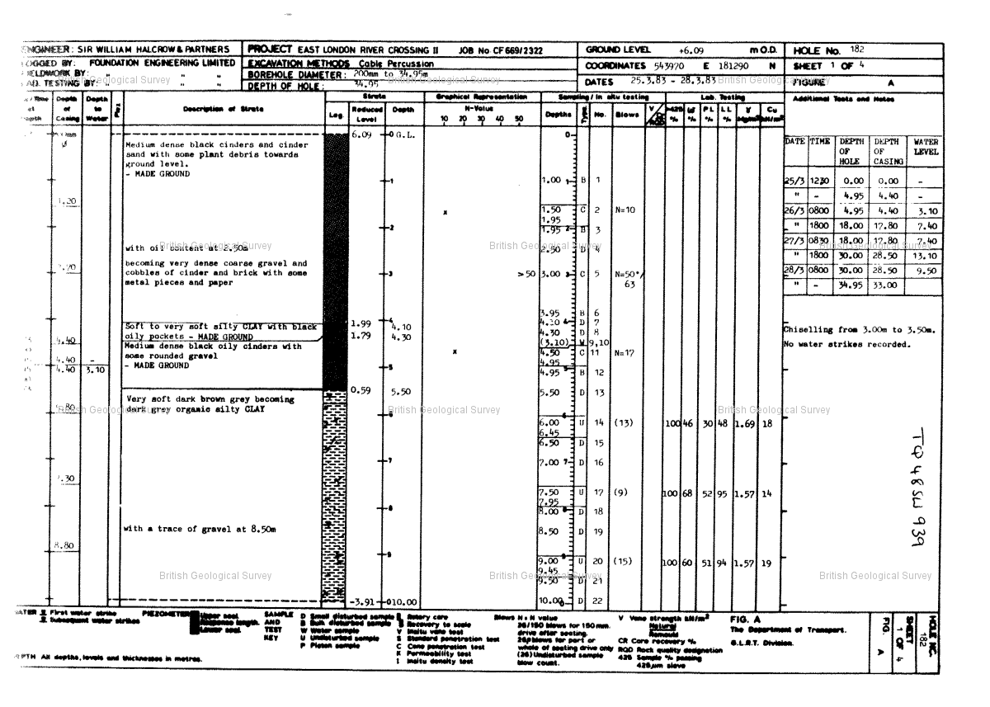

Reference : TQ48SW939

Name : E LONDON RVR CROSSING BH182

Year : null

Eastings: 543970 Northings: 181290

Sheet 2 of 4

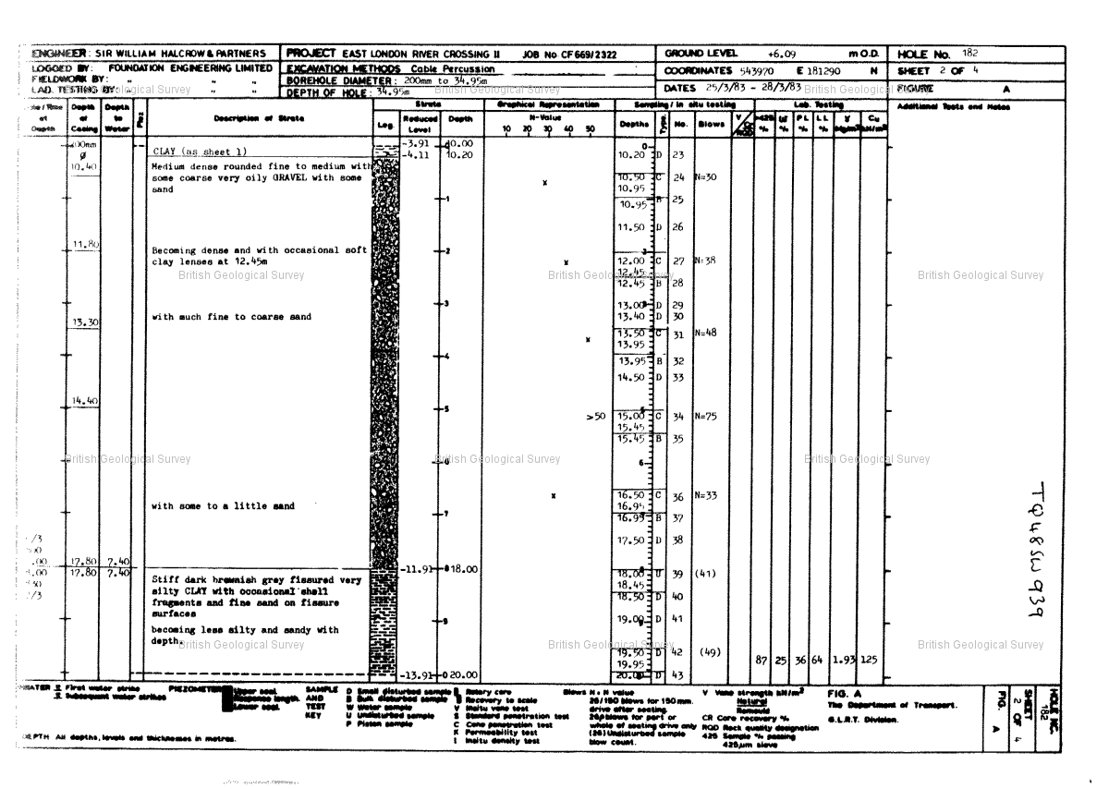

Reference : TQ48SW939

Name : E LONDON RVR CROSSING BH182

Year : null

Eastings: 543970 Northings: 181290

Sheet 3 of 4

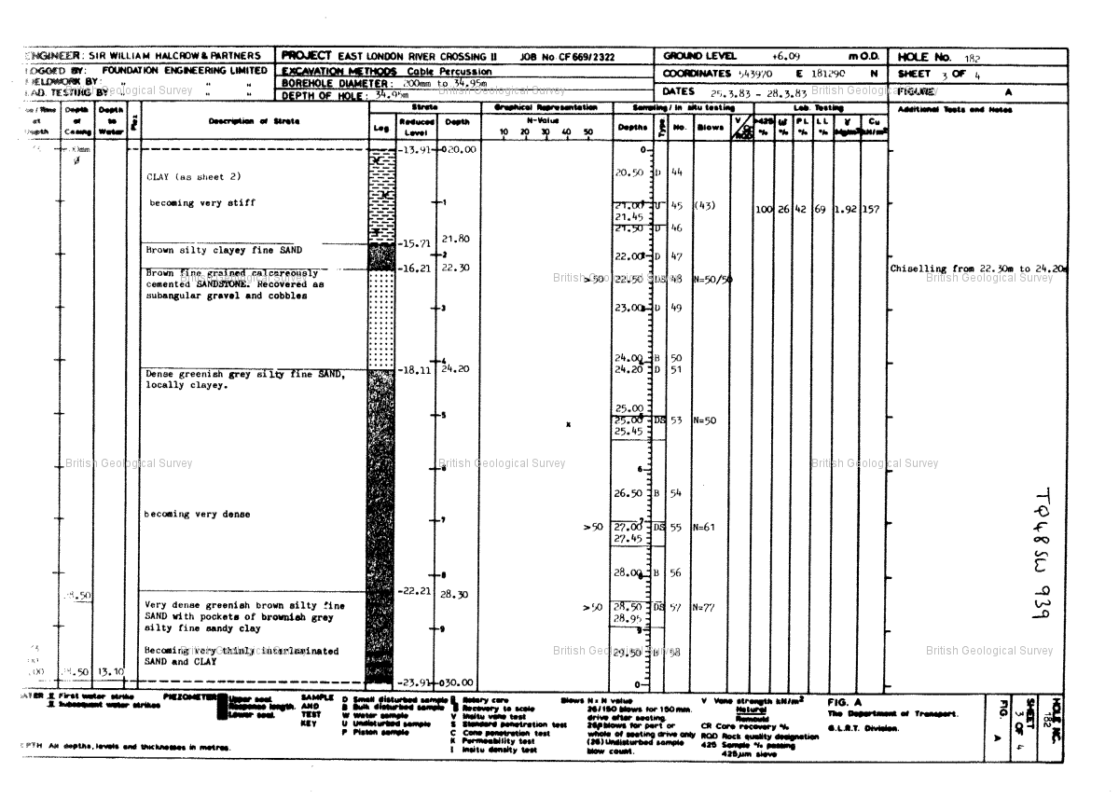

Reference : TQ48SW939

Name : E LONDON RVR CROSSING BH182

Year : null

Eastings: 543970 Northings: 181290

Sheet 4 of 4

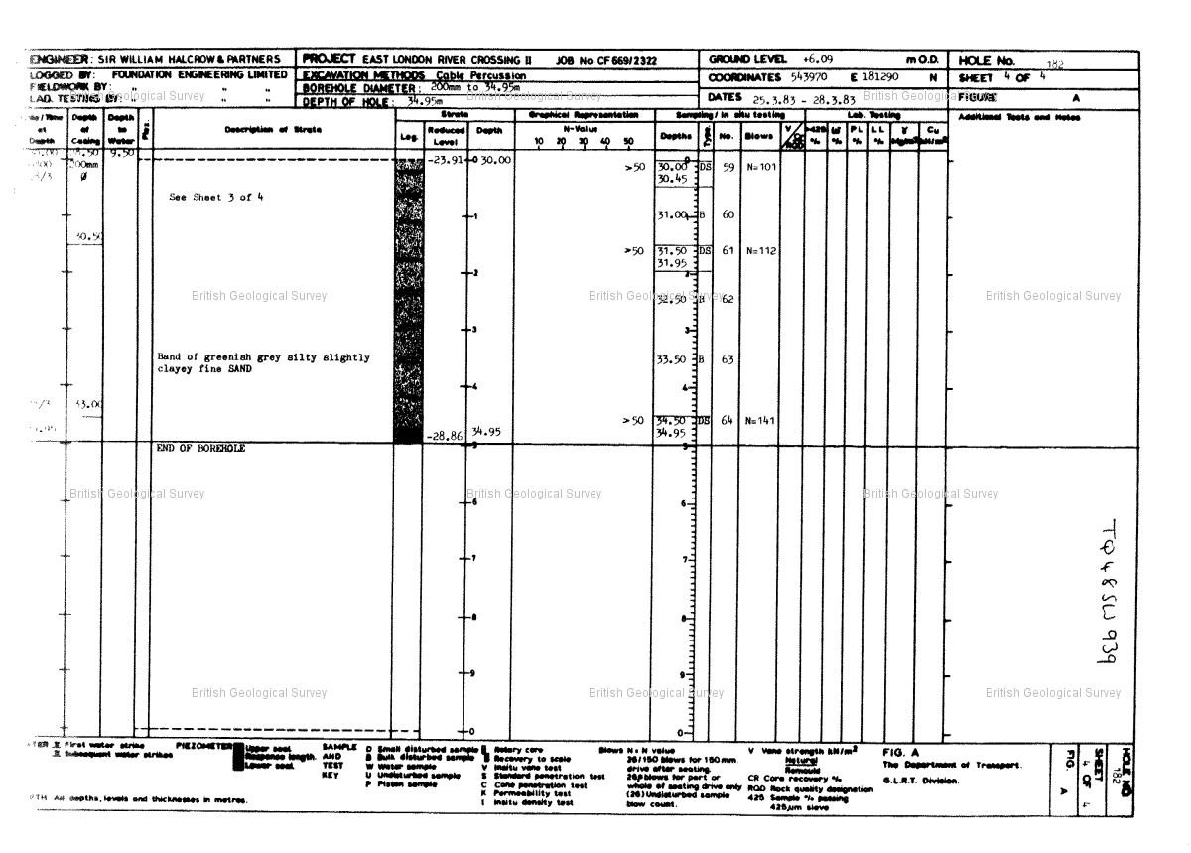

Reference : TQ48SW2527

Name : DLR BECKTON EXTENSION TP33

Year : 1987

Eastings: 543980 Northings: 181280

Sheet 1 of 8

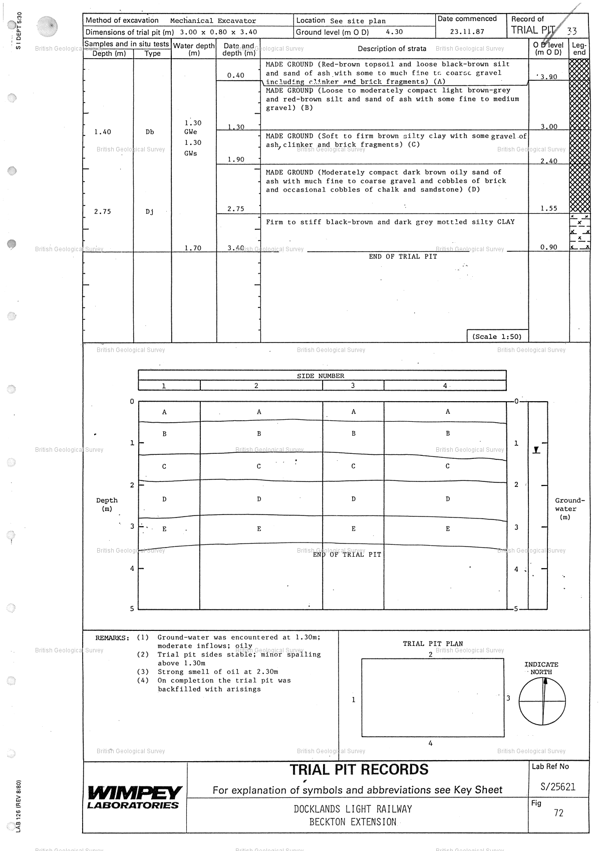

Reference : TQ48SW2527

Name : DLR BECKTON EXTENSION TP33

Year : 1987

Eastings: 543980 Northings: 181280

Sheet 2 of 8

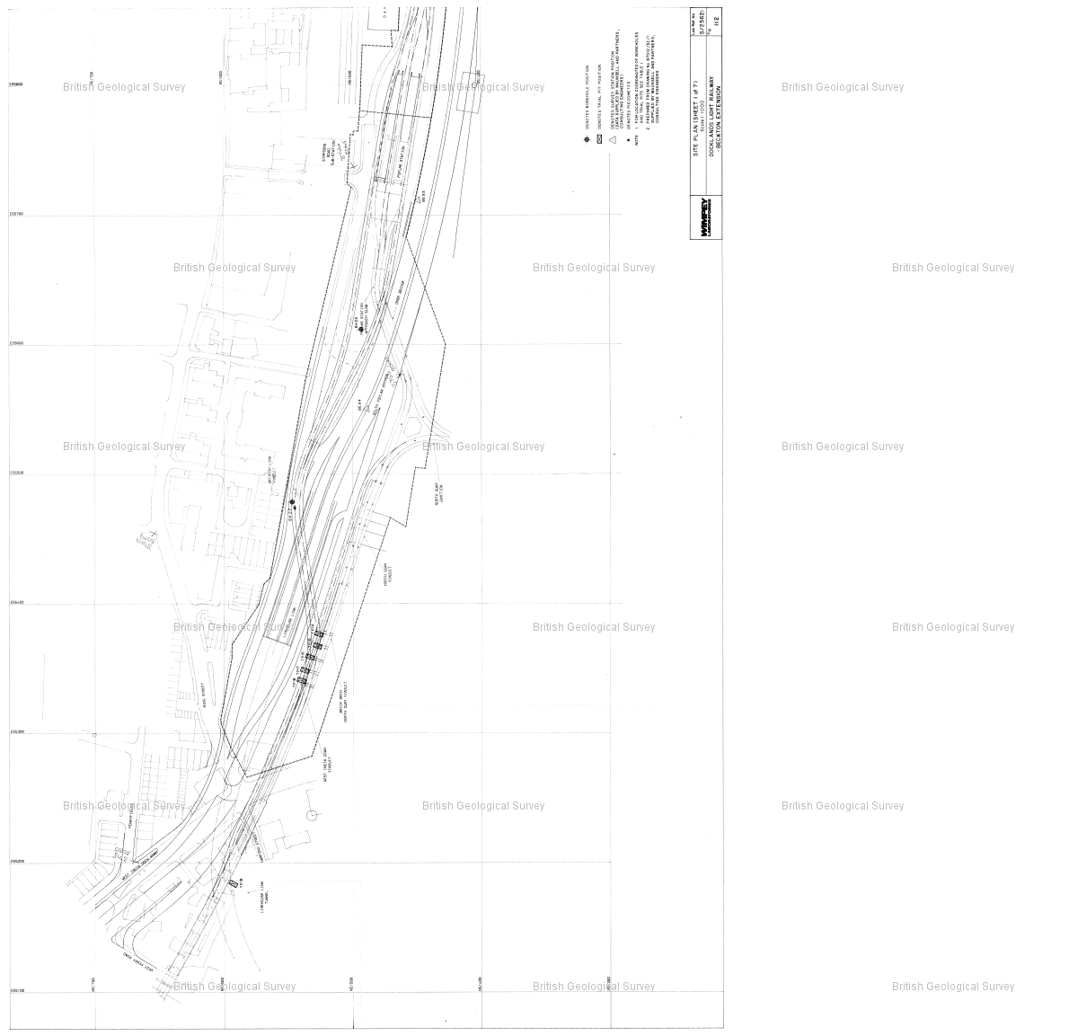

Reference : TQ48SW2527

Name : DLR BECKTON EXTENSION TP33

Year : 1987

Eastings: 543980 Northings: 181280

Sheet 3 of 8

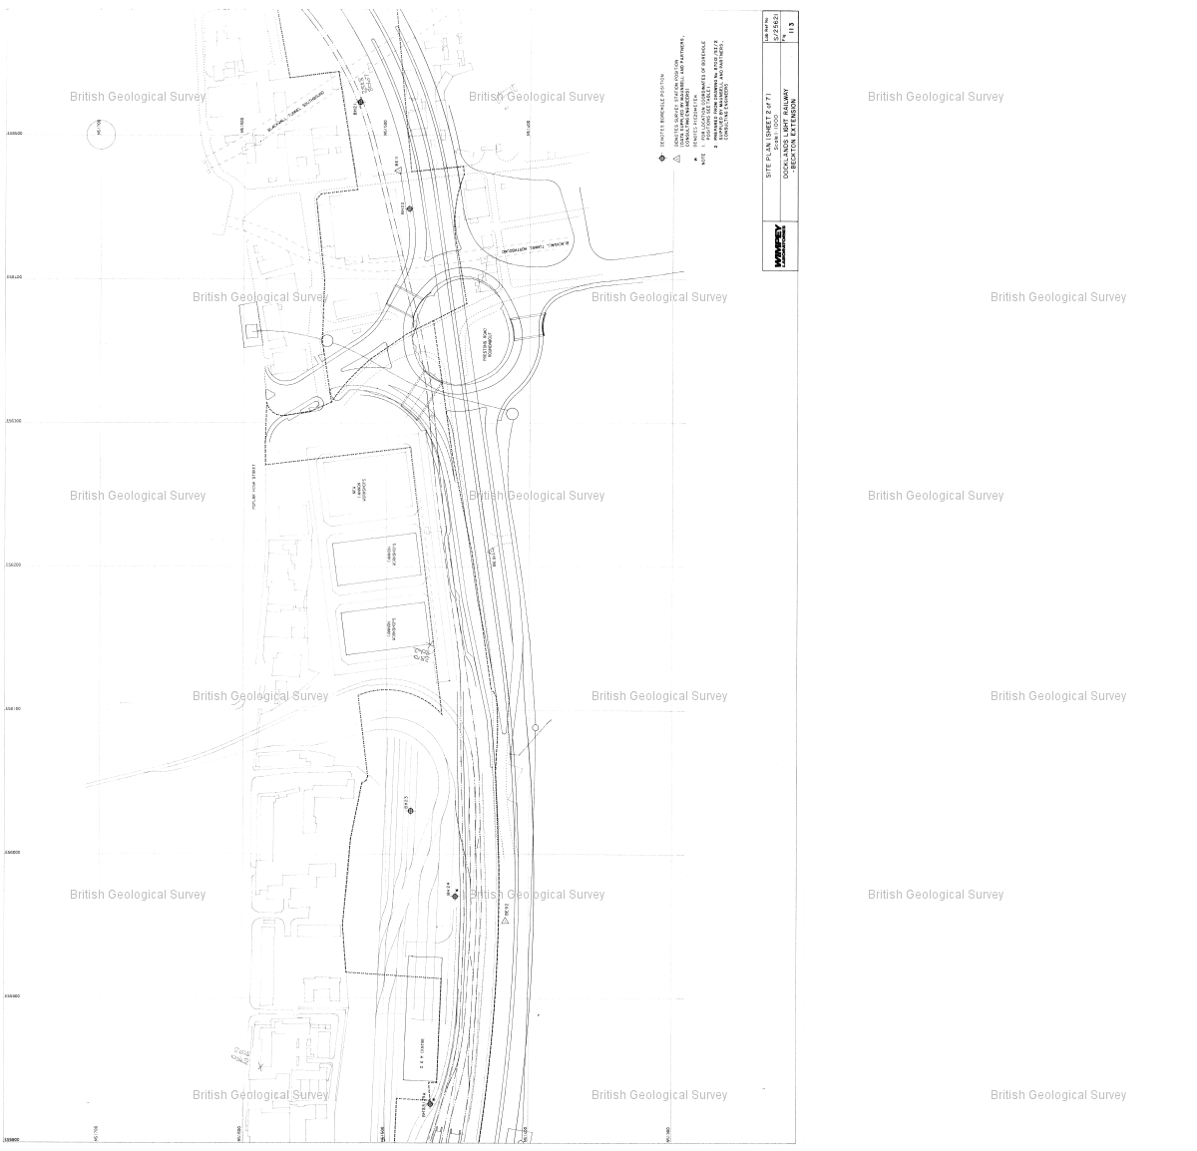

Reference : TQ48SW2527

Name : DLR BECKTON EXTENSION TP33

Year : 1987

Eastings: 543980 Northings: 181280

Sheet 4 of 8

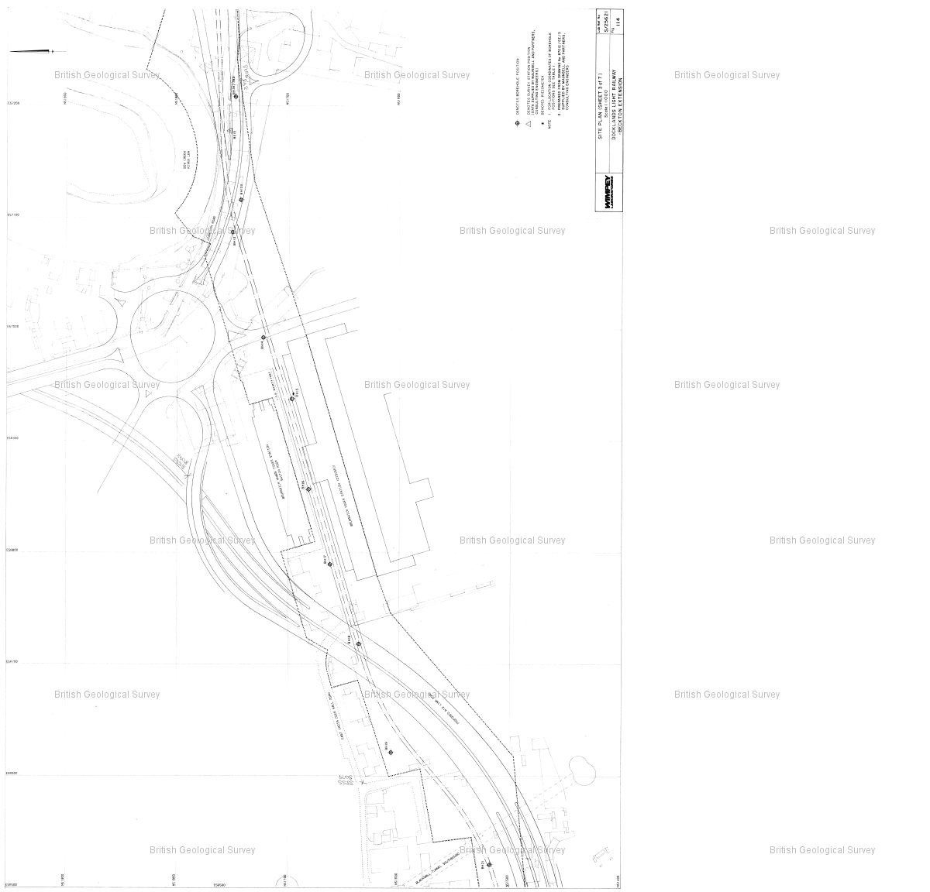

Reference : TQ48SW2527

Name : DLR BECKTON EXTENSION TP33

Year : 1987

Eastings: 543980 Northings: 181280

Sheet 5 of 8

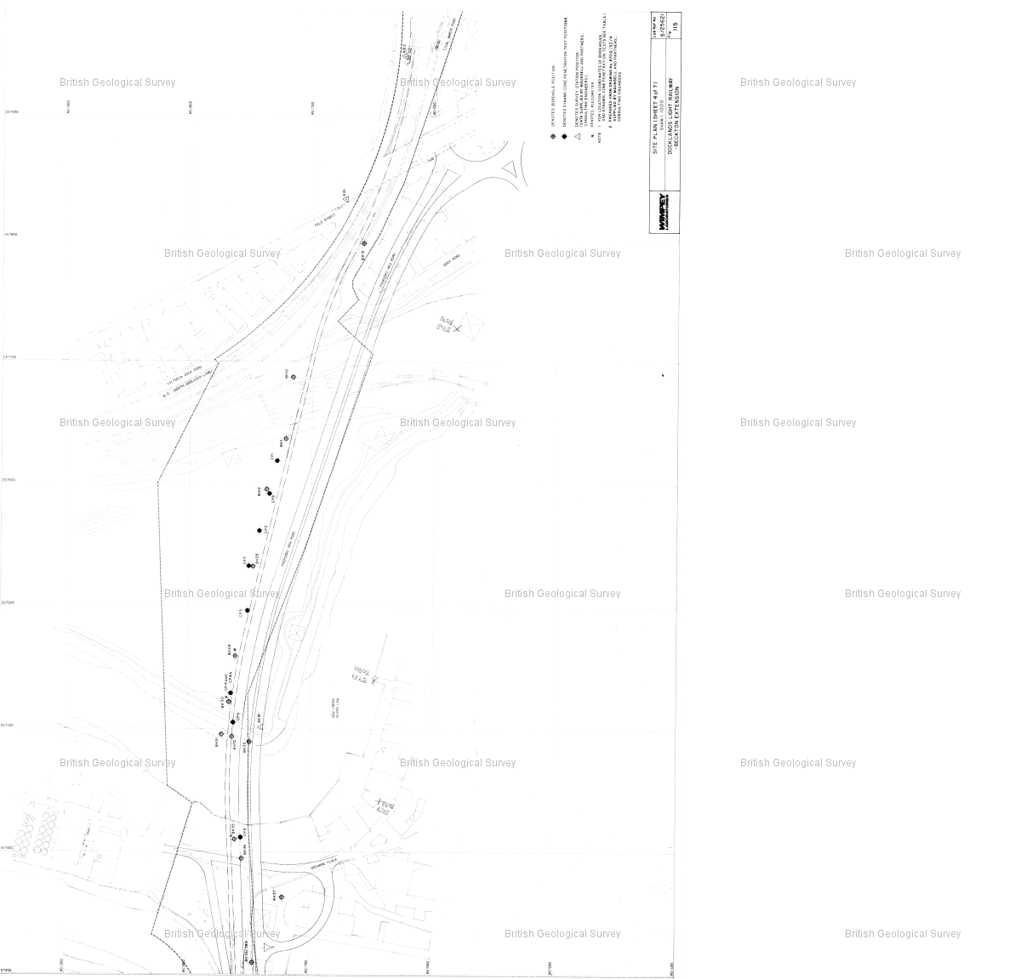

Reference : TQ48SW2527

Name : DLR BECKTON EXTENSION TP33

Year : 1987

Eastings: 543980 Northings: 181280

Sheet 6 of 8

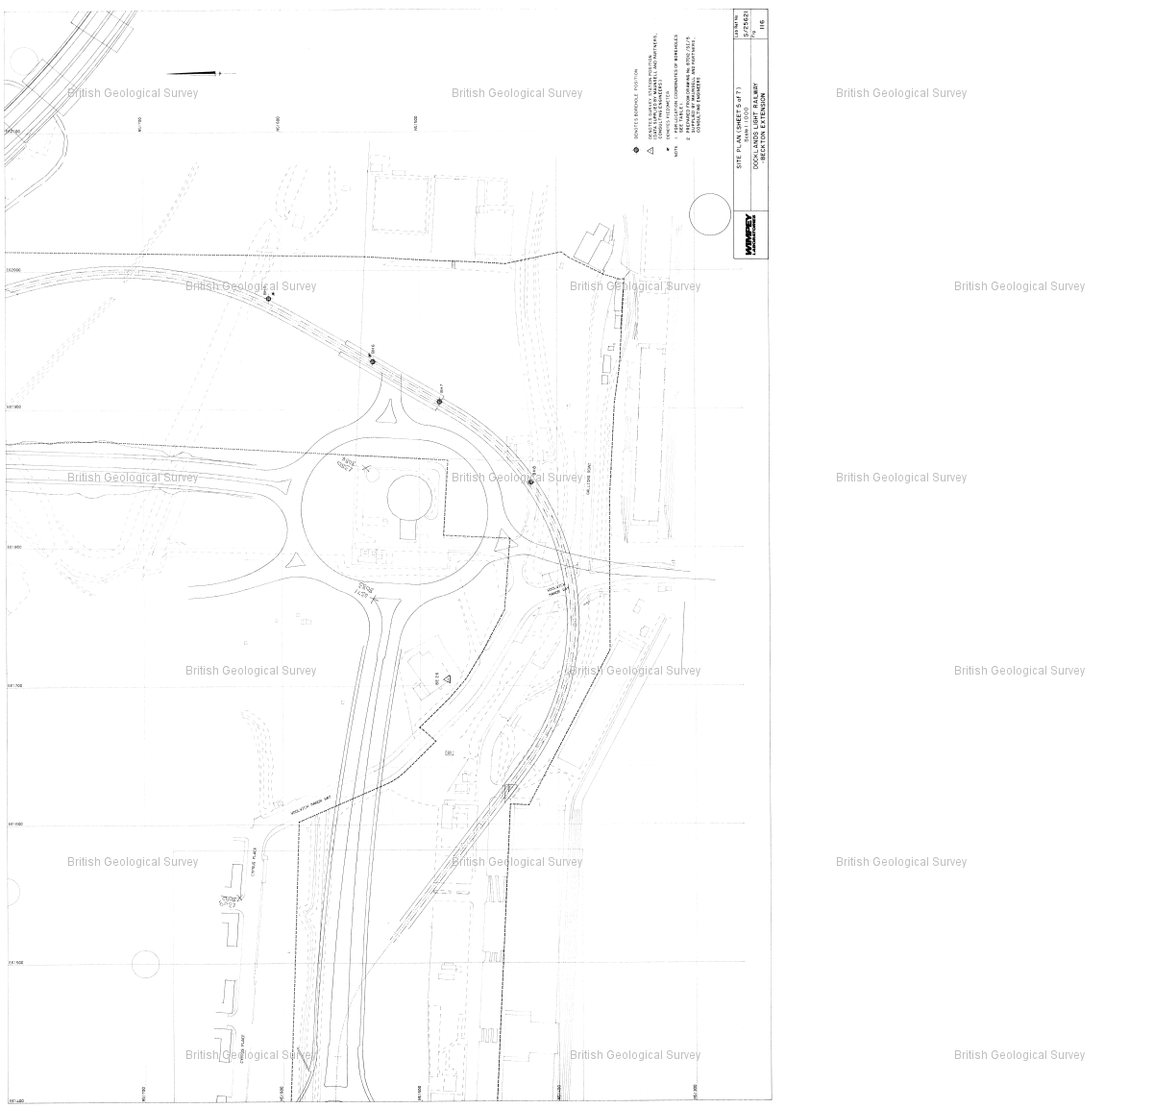

Reference : TQ48SW2527

Name : DLR BECKTON EXTENSION TP33

Year : 1987

Eastings: 543980 Northings: 181280

Sheet 7 of 8

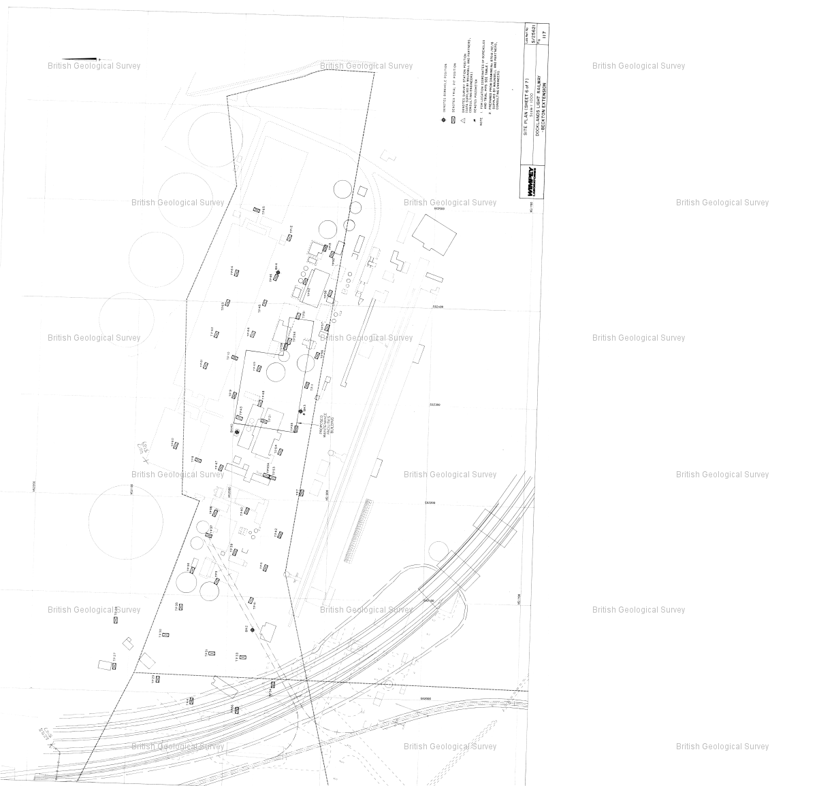

Reference : TQ48SW2527

Name : DLR BECKTON EXTENSION TP33

Year : 1987

Eastings: 543980 Northings: 181280

Sheet 8 of 8

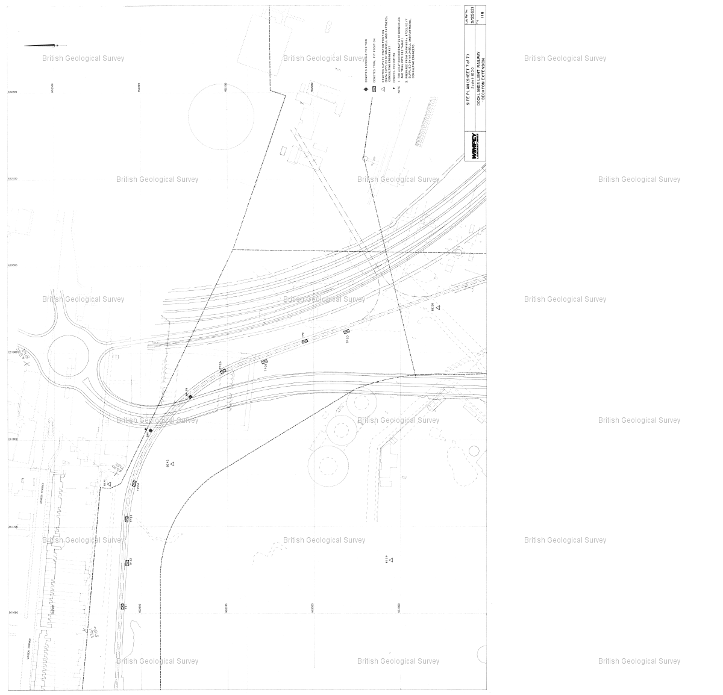

Reference : TQ48SW2494

Name : DLR BECKTON EXTENSION BH2

Year : 1987

Eastings: 544010 Northings: 181270

Sheet 1 of 9

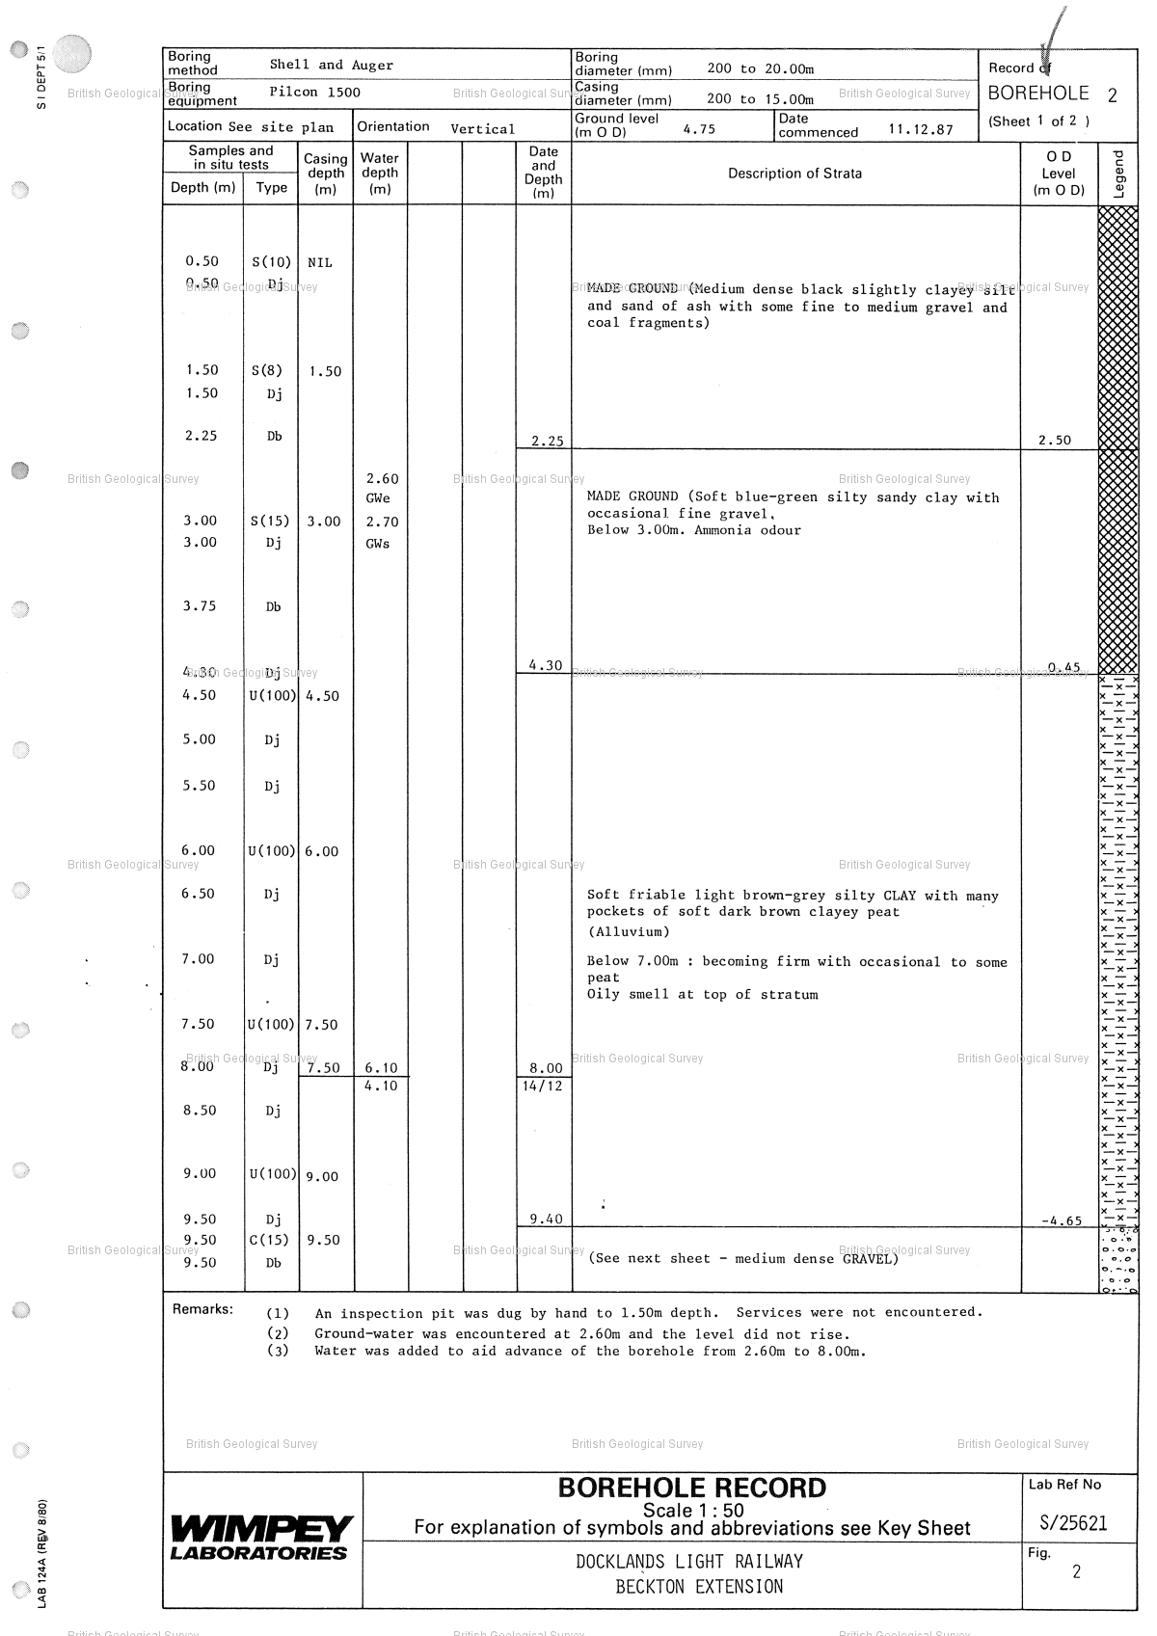

Reference : TQ48SW2494

Name : DLR BECKTON EXTENSION BH2

Year : 1987

Eastings: 544010 Northings: 181270

Sheet 2 of 9

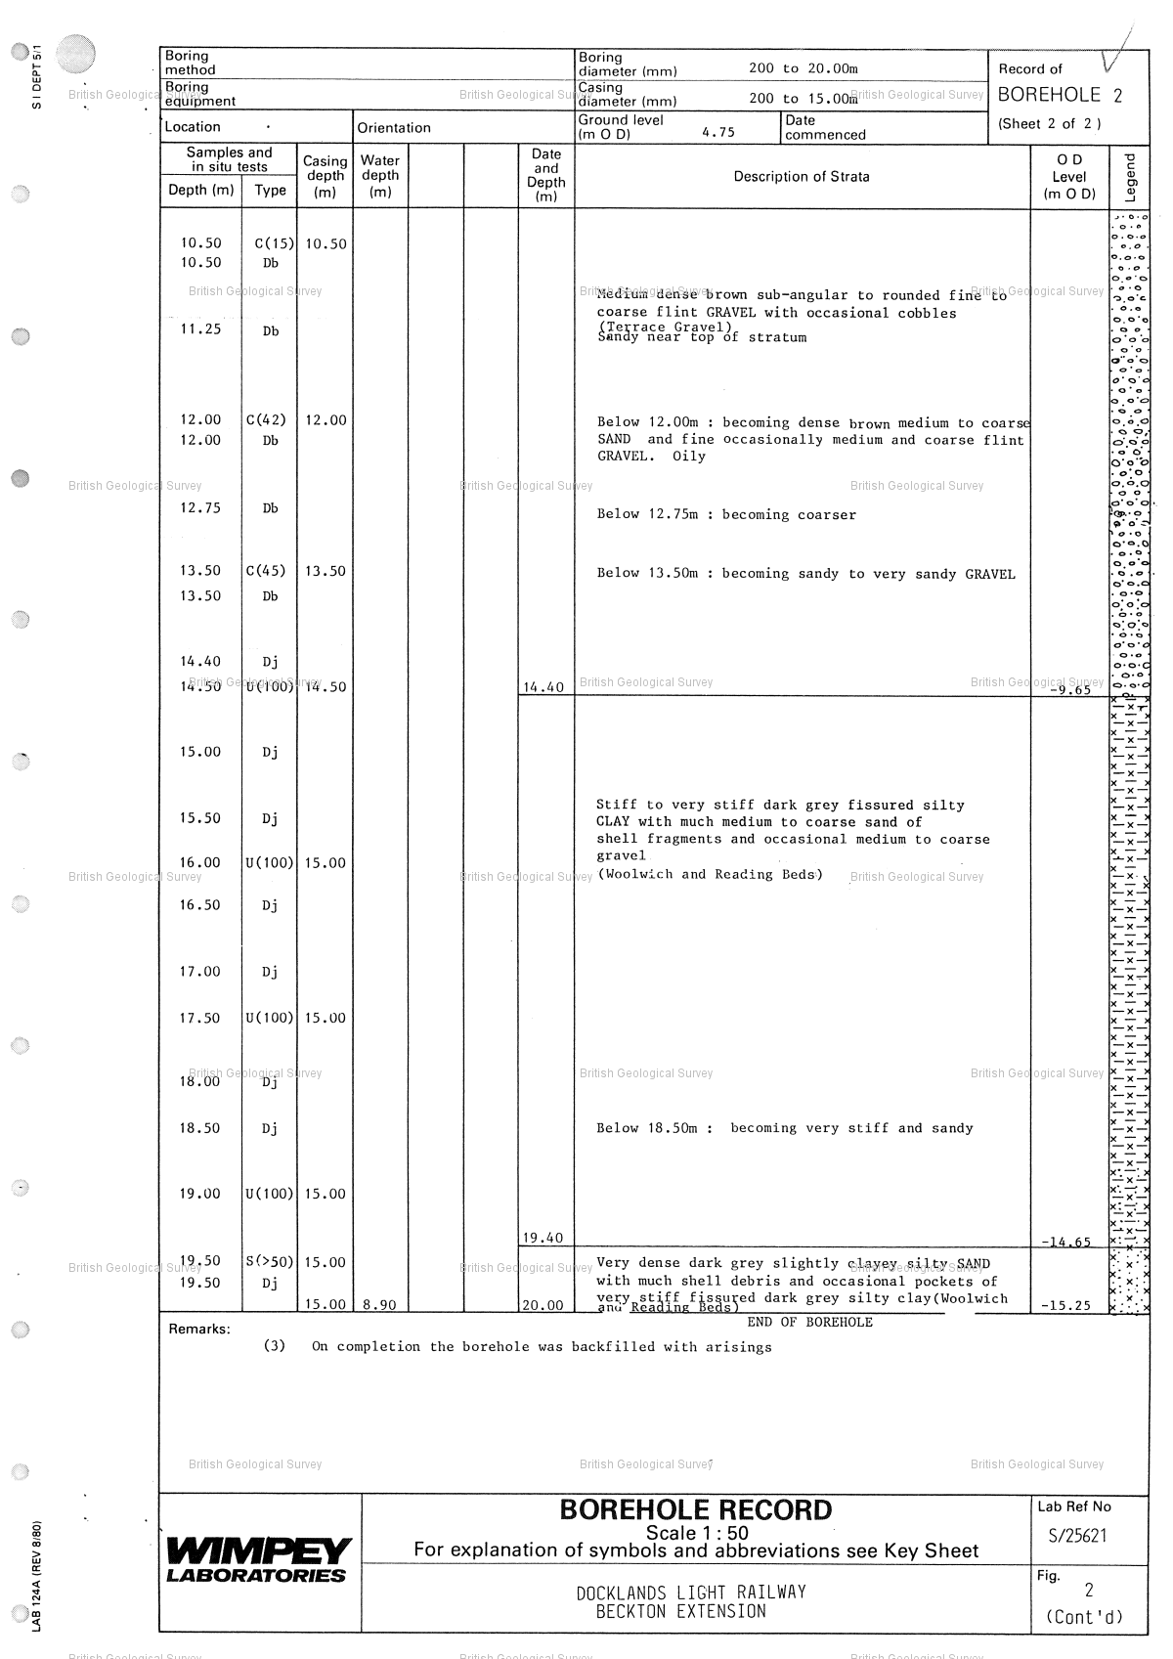

Reference : TQ48SW2494

Name : DLR BECKTON EXTENSION BH2

Year : 1987

Eastings: 544010 Northings: 181270

Sheet 3 of 9

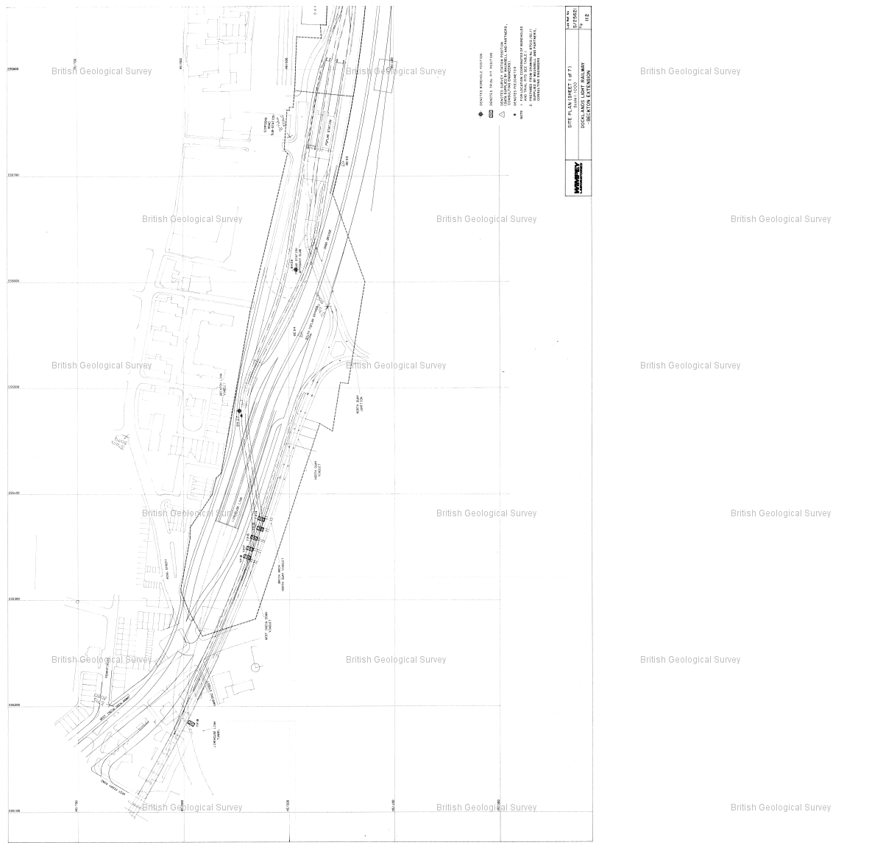

Reference : TQ48SW2494

Name : DLR BECKTON EXTENSION BH2

Year : 1987

Eastings: 544010 Northings: 181270

Sheet 4 of 9

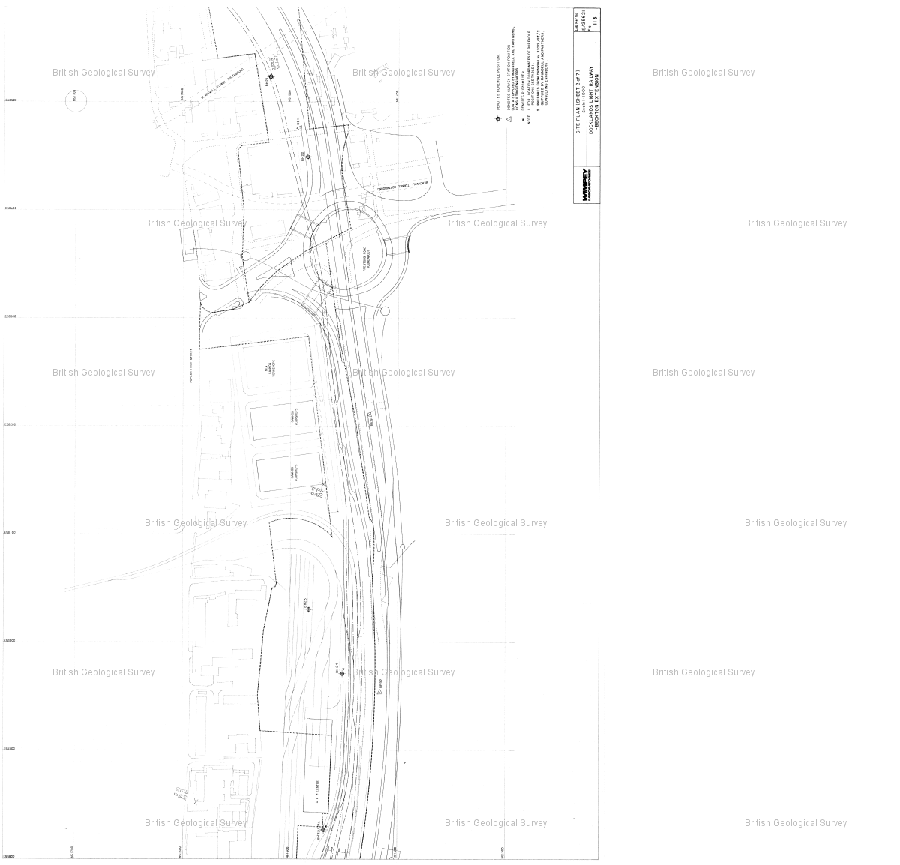

Reference : TQ48SW2494

Name : DLR BECKTON EXTENSION BH2

Year : 1987

Eastings: 544010 Northings: 181270

Sheet 5 of 9

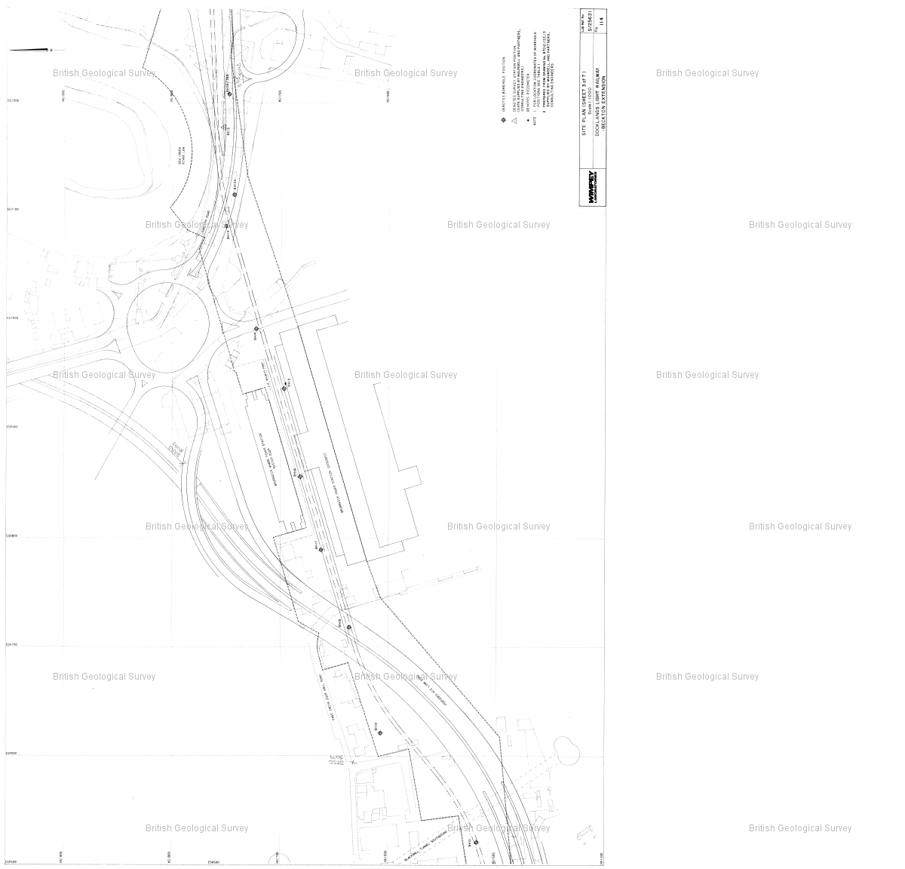

Reference : TQ48SW2494

Name : DLR BECKTON EXTENSION BH2

Year : 1987

Eastings: 544010 Northings: 181270

Sheet 6 of 9

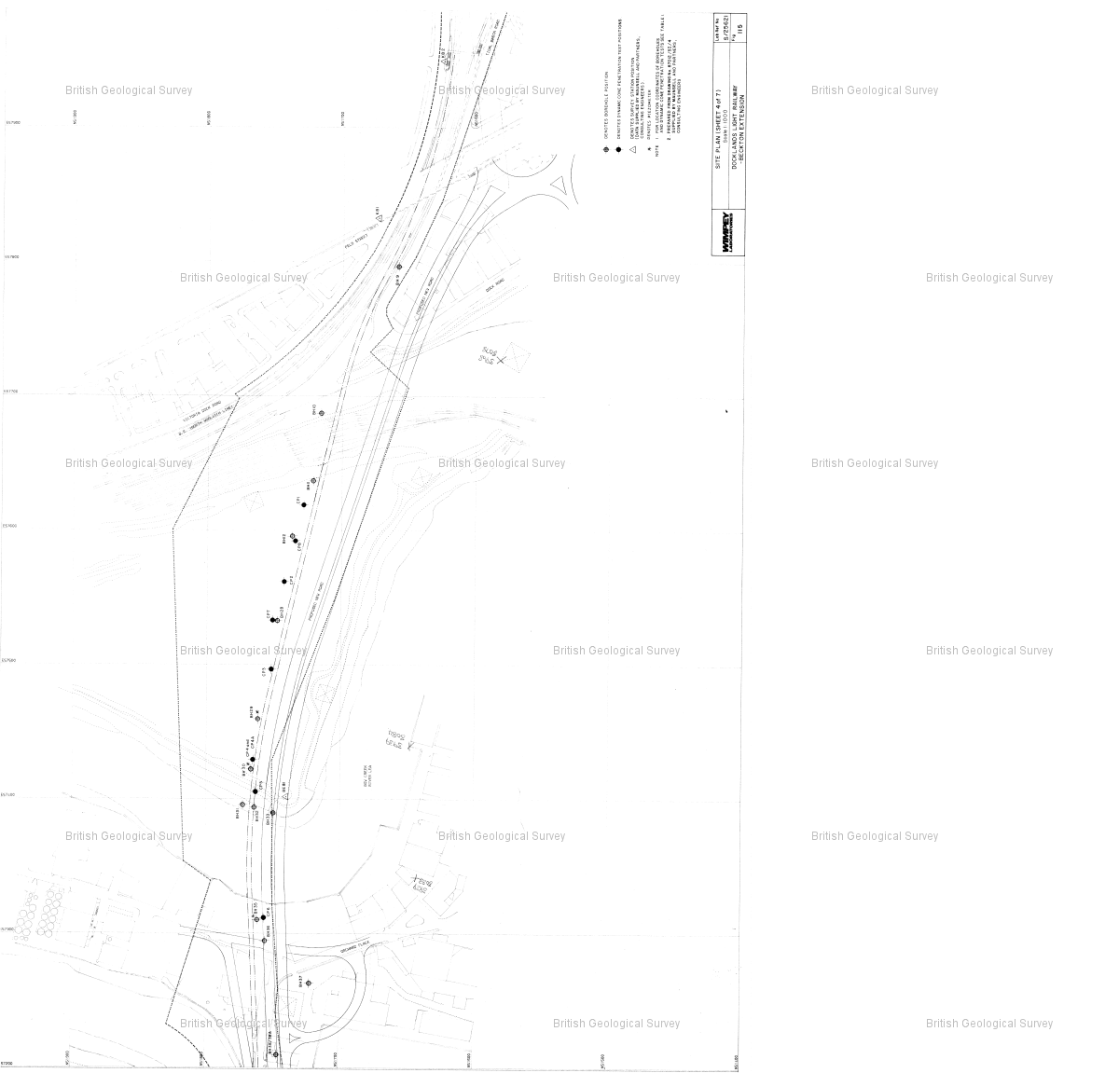

Reference : TQ48SW2494

Name : DLR BECKTON EXTENSION BH2

Year : 1987

Eastings: 544010 Northings: 181270

Sheet 7 of 9

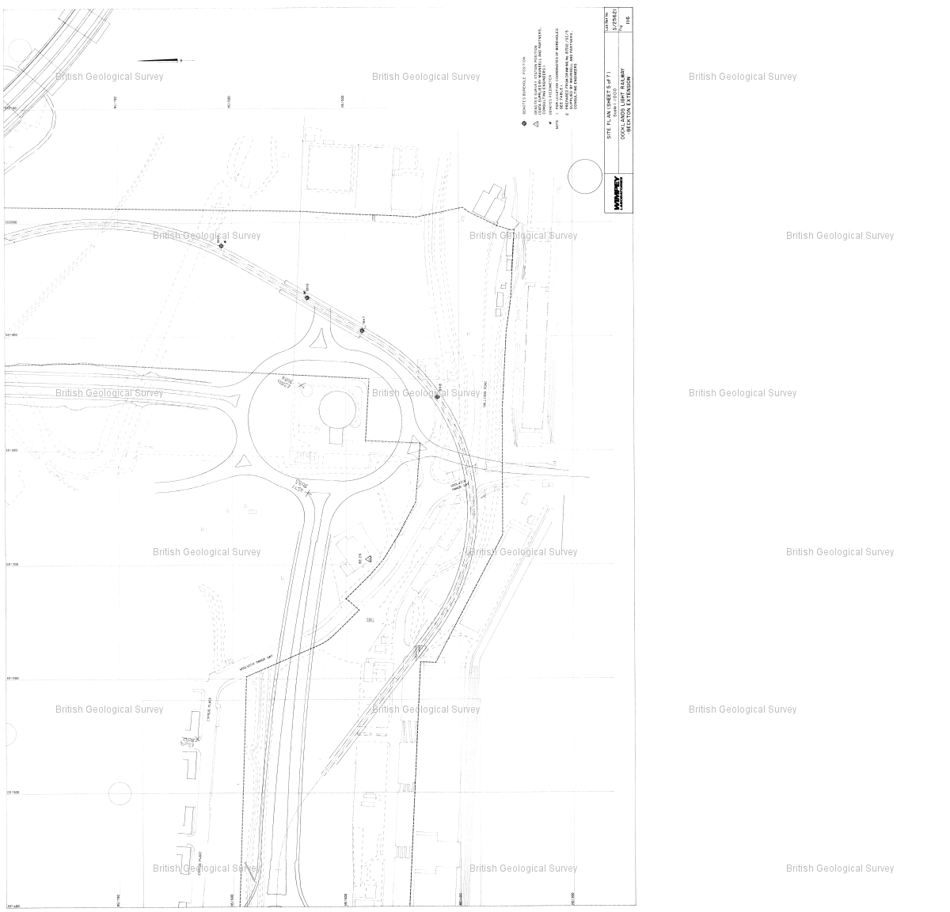

Reference : TQ48SW2494

Name : DLR BECKTON EXTENSION BH2

Year : 1987

Eastings: 544010 Northings: 181270

Sheet 8 of 9

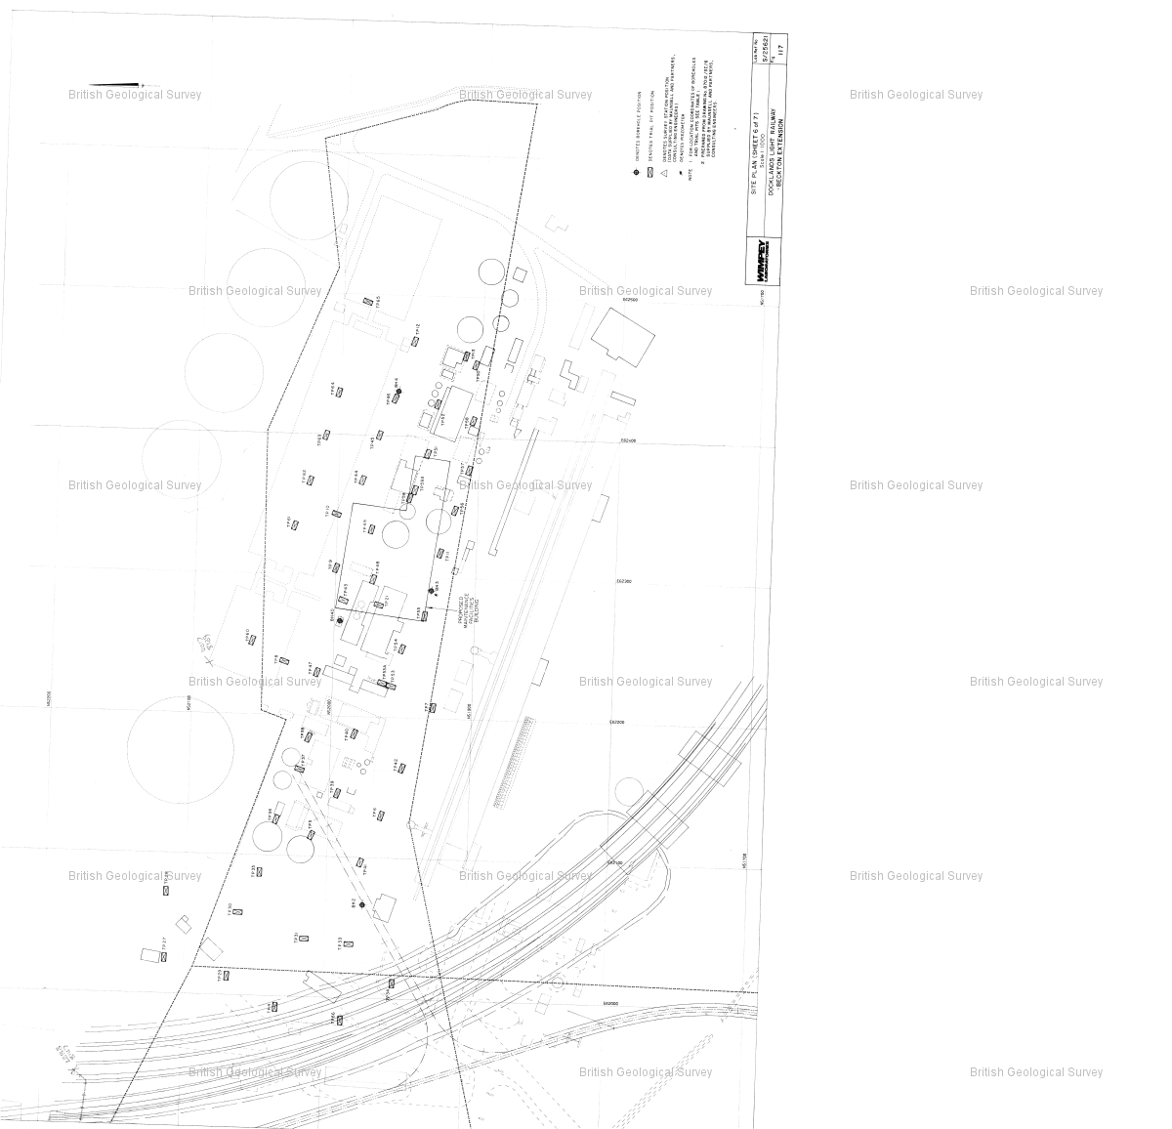

Reference : TQ48SW2494

Name : DLR BECKTON EXTENSION BH2

Year : 1987

Eastings: 544010 Northings: 181270

Sheet 9 of 9

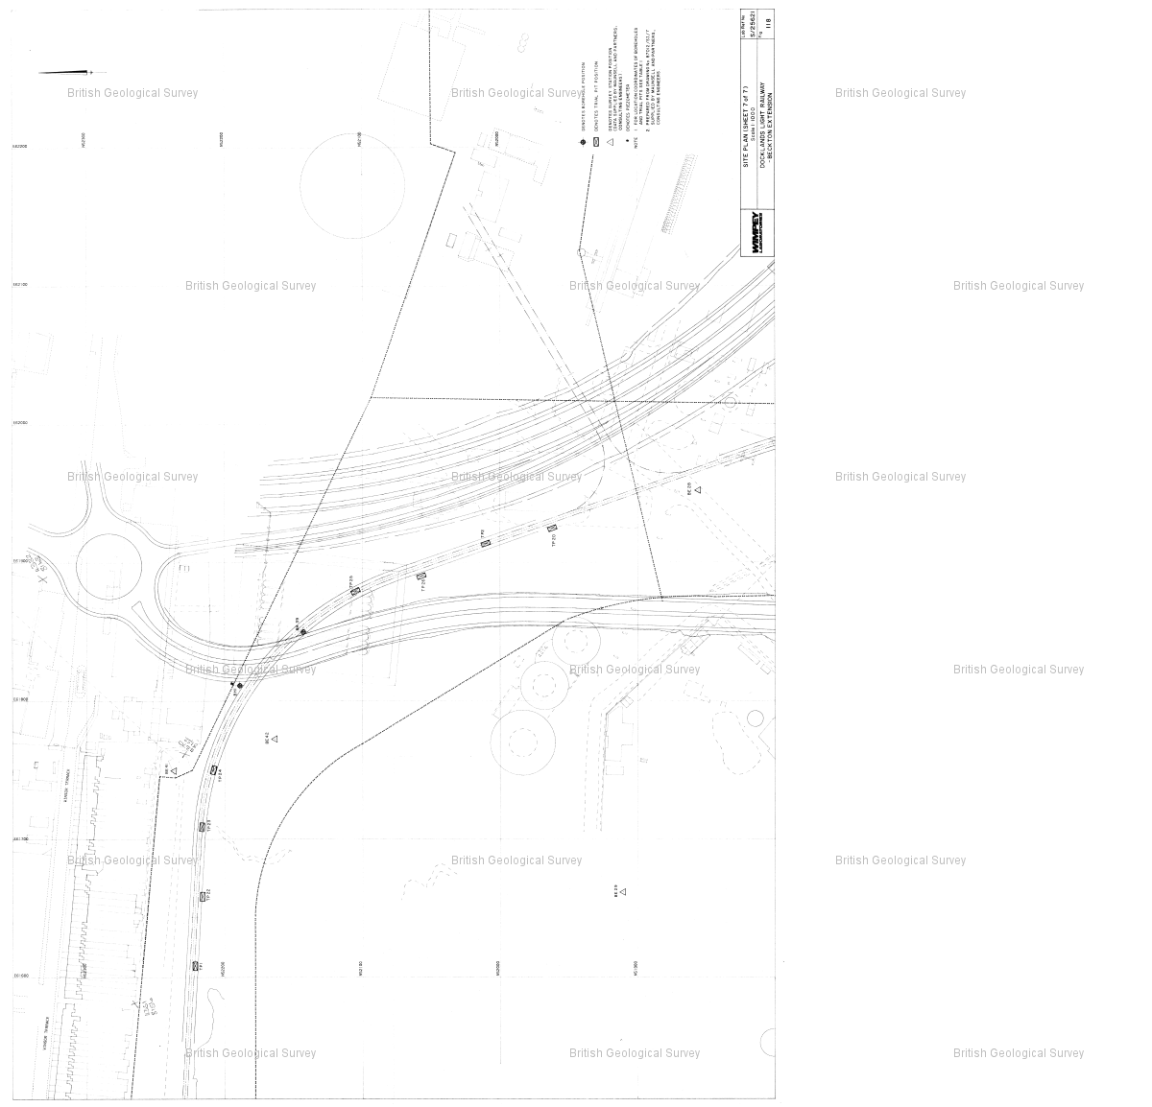

Reference : TQ48SW2507

Name : DLR BECKTON EXTENSION TP6

Year : 1987

Eastings: 544070 Northings: 181260

Sheet 1 of 8

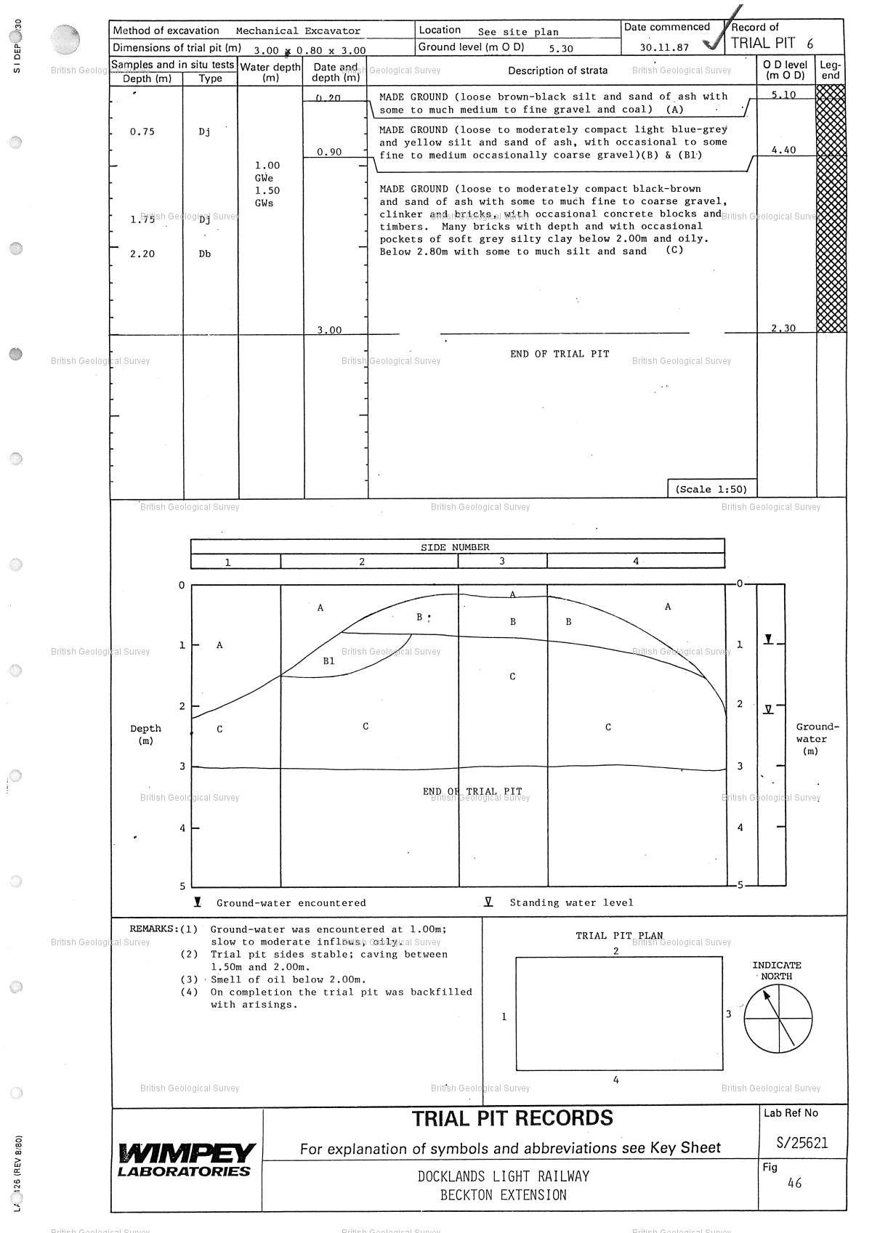

Reference : TQ48SW2507

Name : DLR BECKTON EXTENSION TP6

Year : 1987

Eastings: 544070 Northings: 181260

Sheet 2 of 8

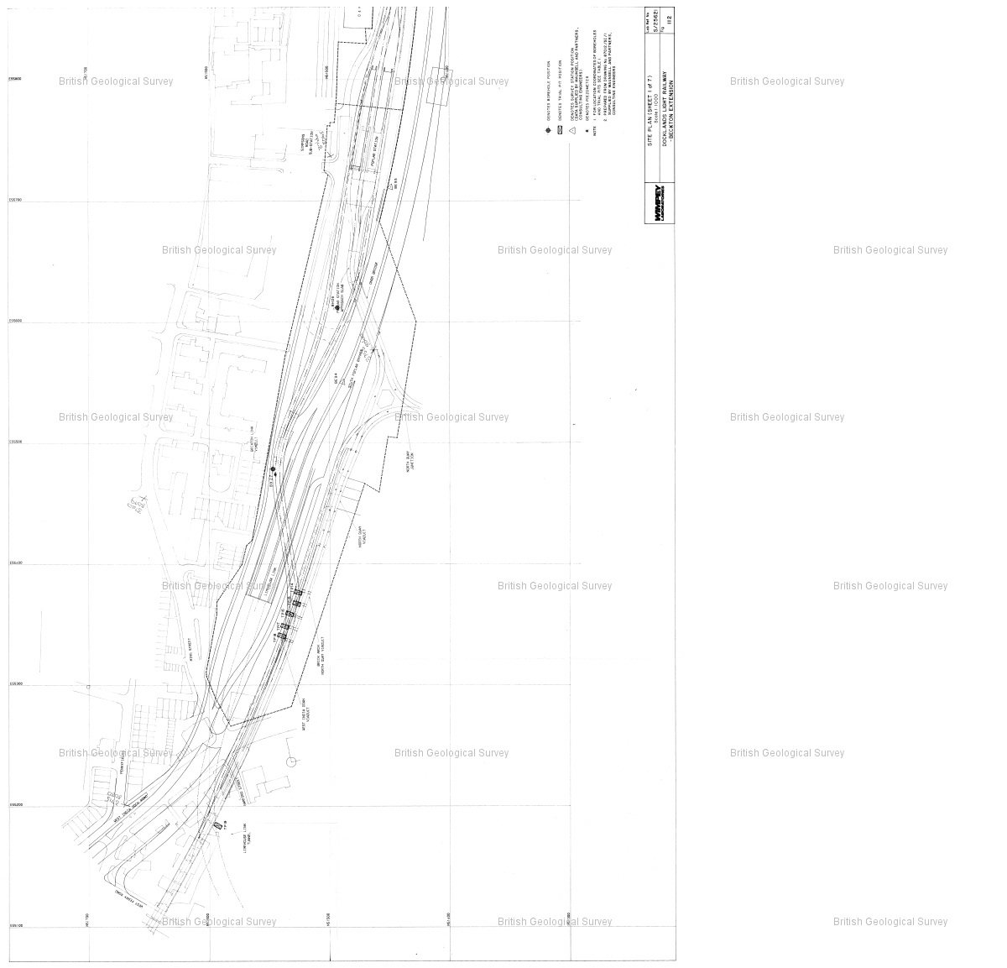

Reference : TQ48SW2507

Name : DLR BECKTON EXTENSION TP6

Year : 1987

Eastings: 544070 Northings: 181260

Sheet 3 of 8

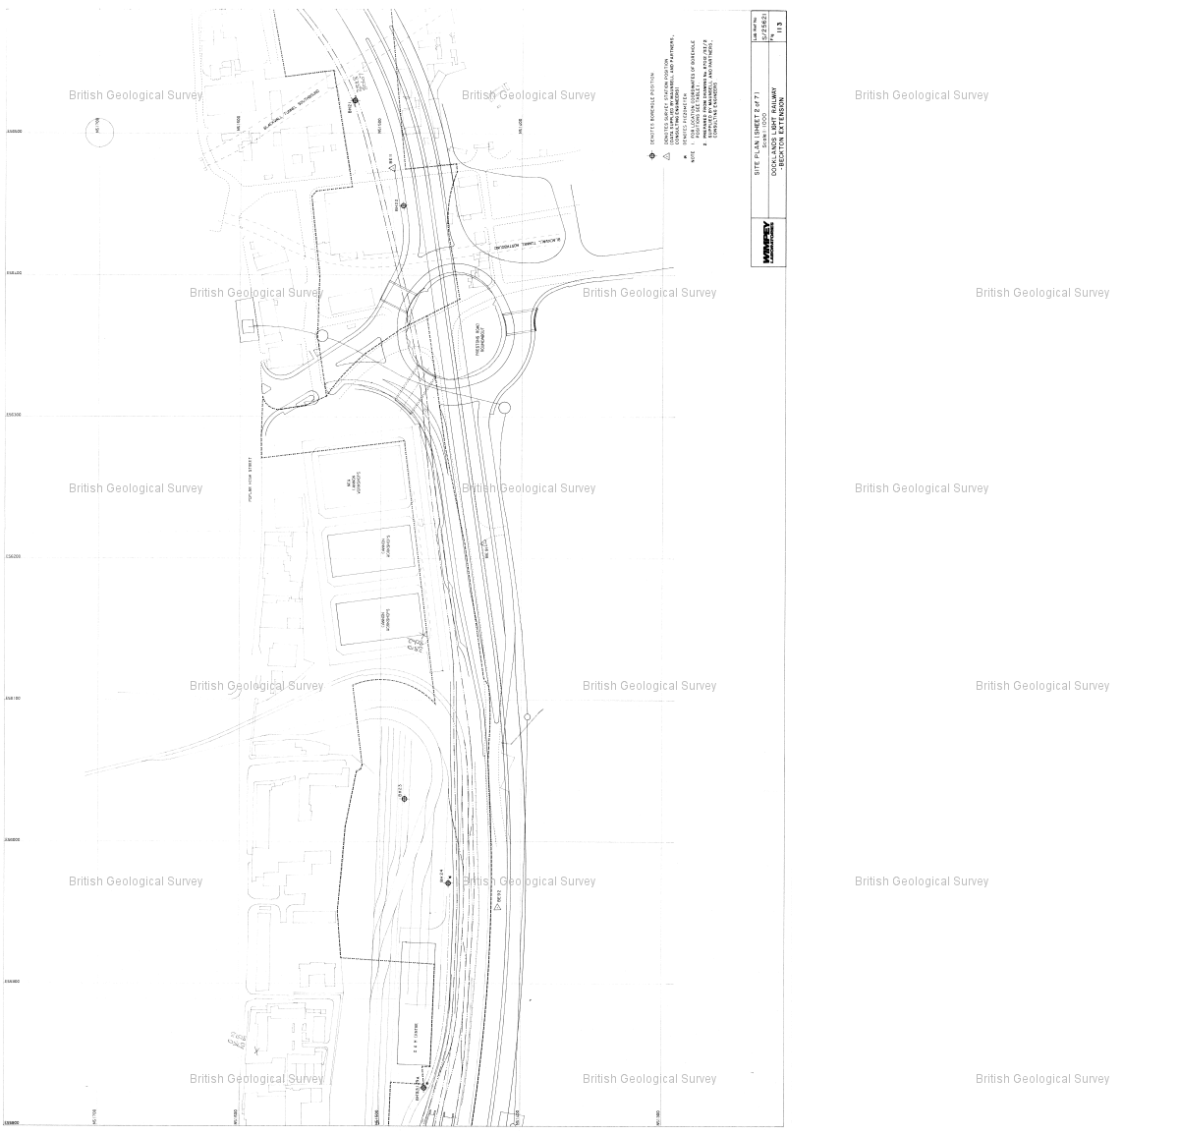

Reference : TQ48SW2507

Name : DLR BECKTON EXTENSION TP6

Year : 1987

Eastings: 544070 Northings: 181260

Sheet 4 of 8

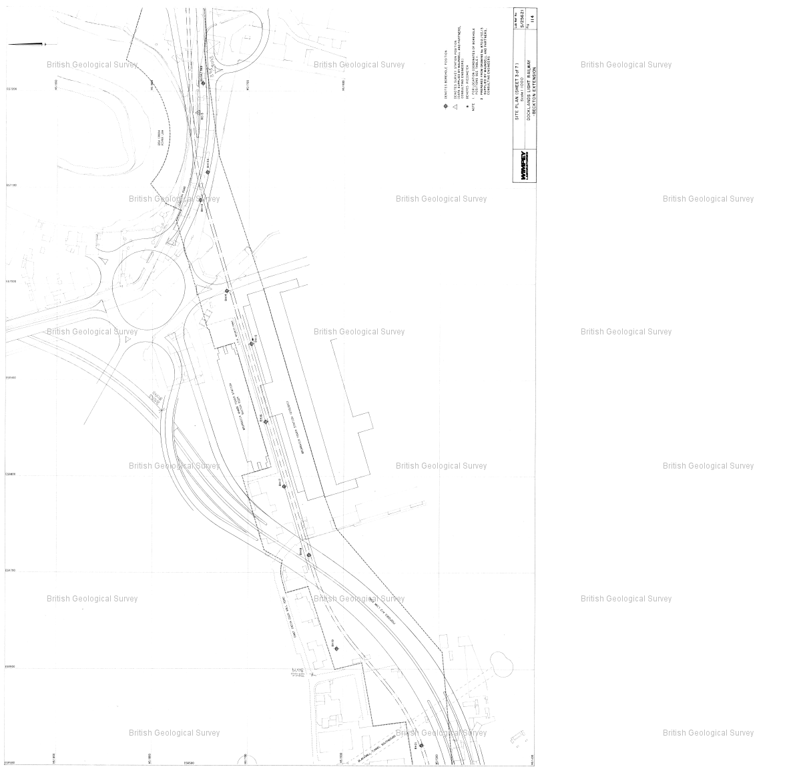

Reference : TQ48SW2507

Name : DLR BECKTON EXTENSION TP6

Year : 1987

Eastings: 544070 Northings: 181260

Sheet 5 of 8

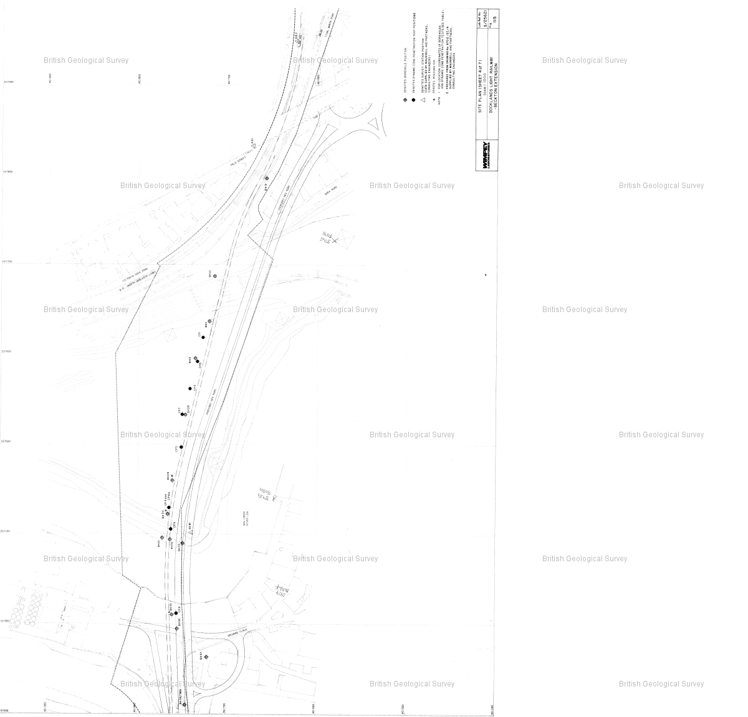

Reference : TQ48SW2507

Name : DLR BECKTON EXTENSION TP6

Year : 1987

Eastings: 544070 Northings: 181260

Sheet 6 of 8

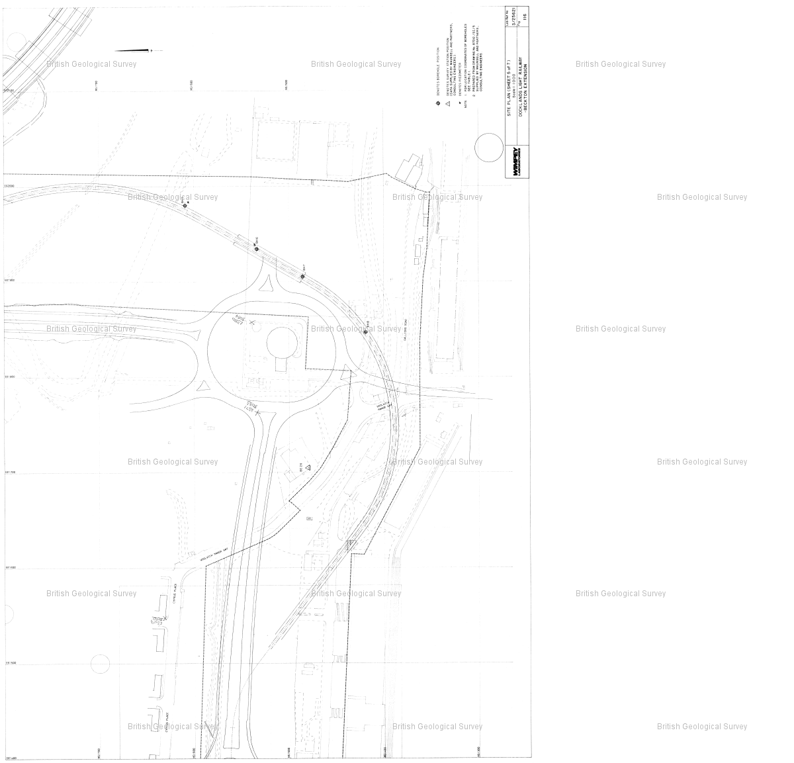

Reference : TQ48SW2507

Name : DLR BECKTON EXTENSION TP6

Year : 1987

Eastings: 544070 Northings: 181260

Sheet 7 of 8

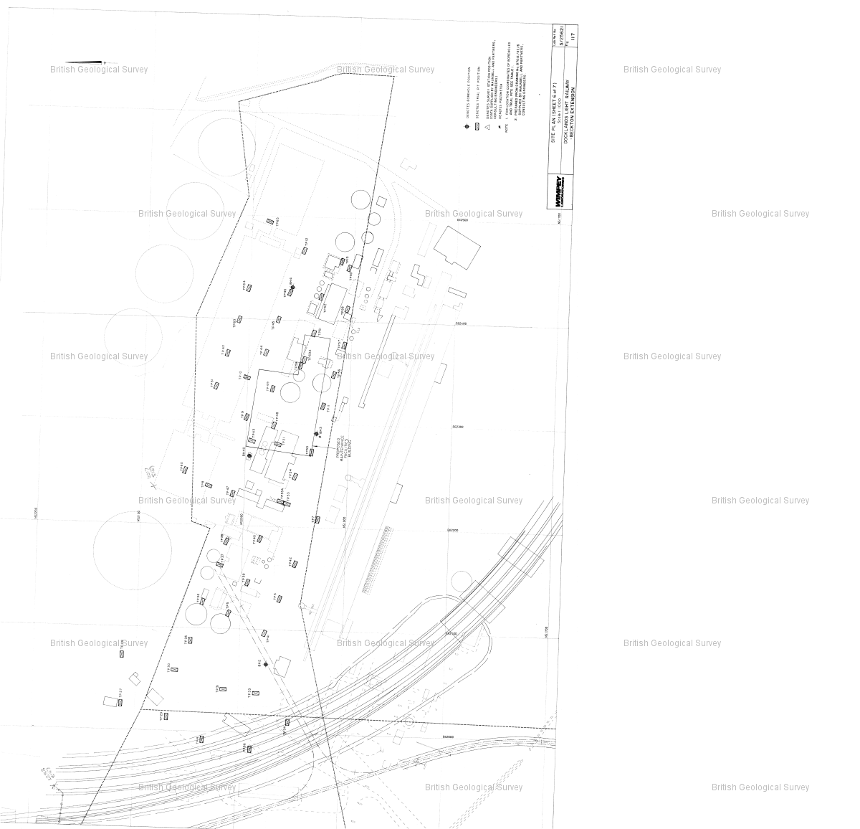

Reference : TQ48SW2507

Name : DLR BECKTON EXTENSION TP6

Year : 1987

Eastings: 544070 Northings: 181260

Sheet 8 of 8

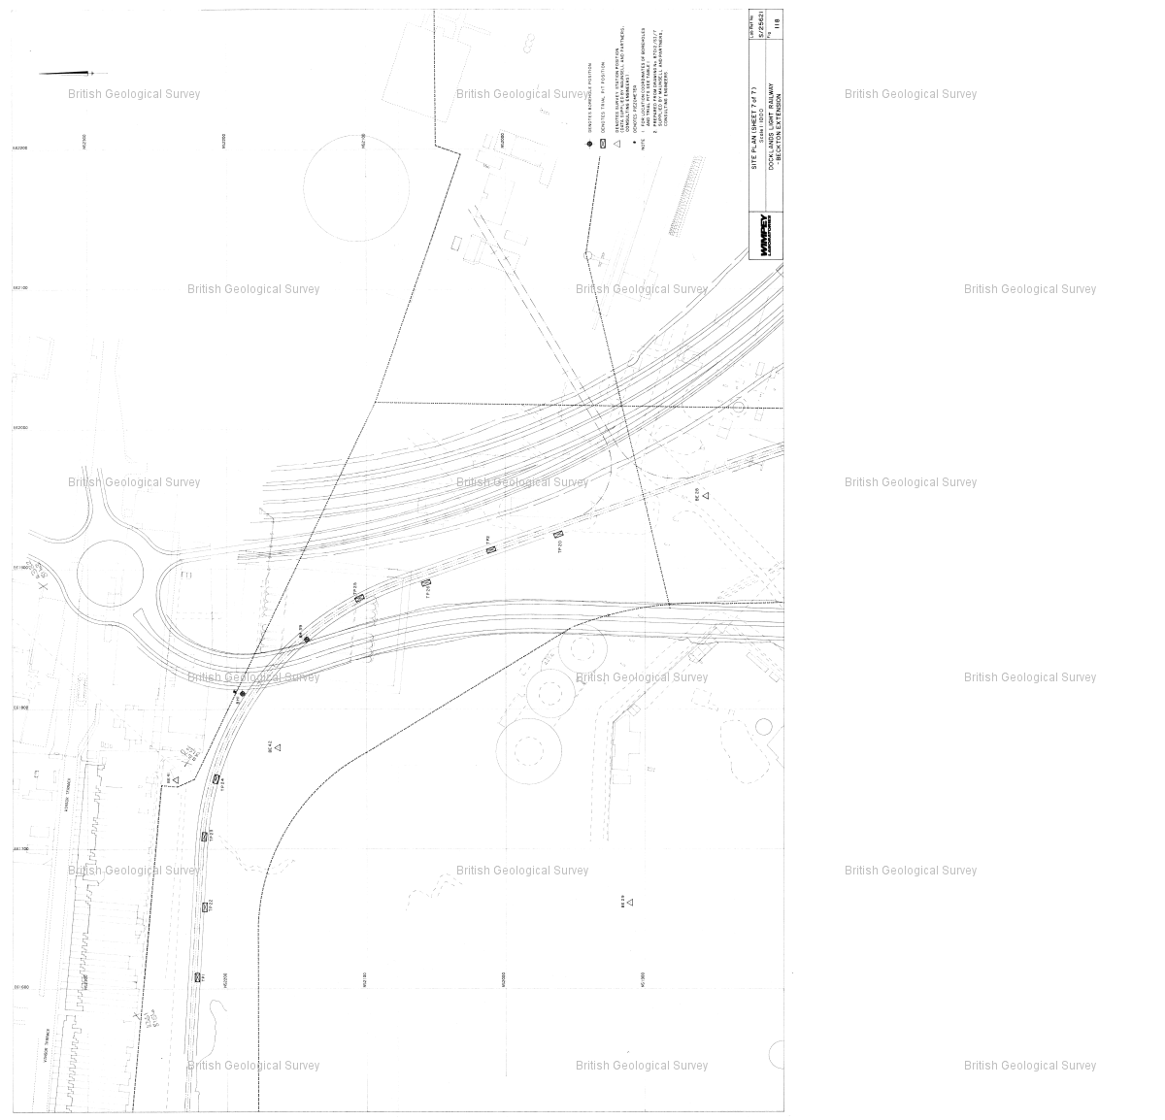

Reference : TQ48SW935

Name : E LONDON RVR CROSSING BH178

Year : null

Eastings: 544023 Northings: 181186

Sheet 1 of 3

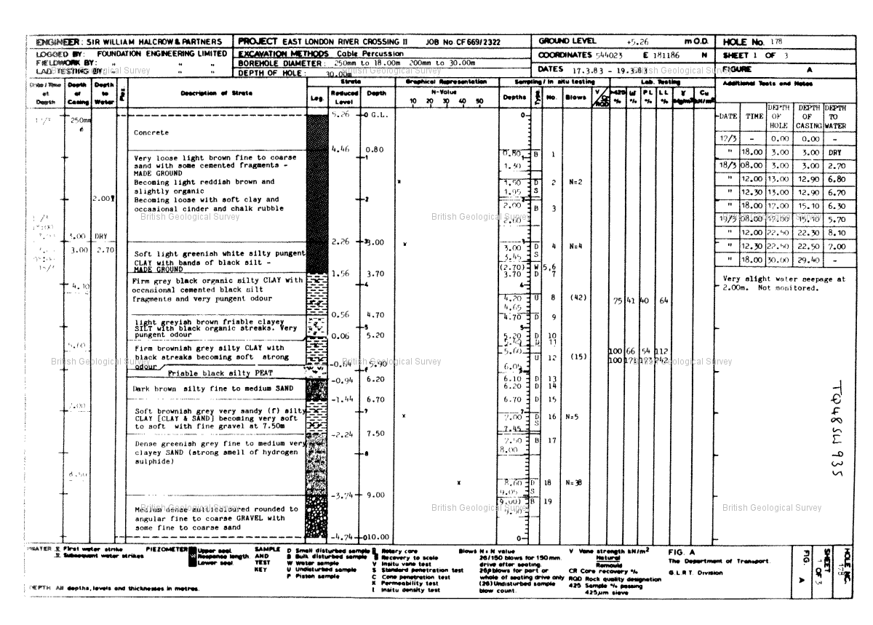

Reference : TQ48SW935

Name : E LONDON RVR CROSSING BH178

Year : null

Eastings: 544023 Northings: 181186

Sheet 2 of 3

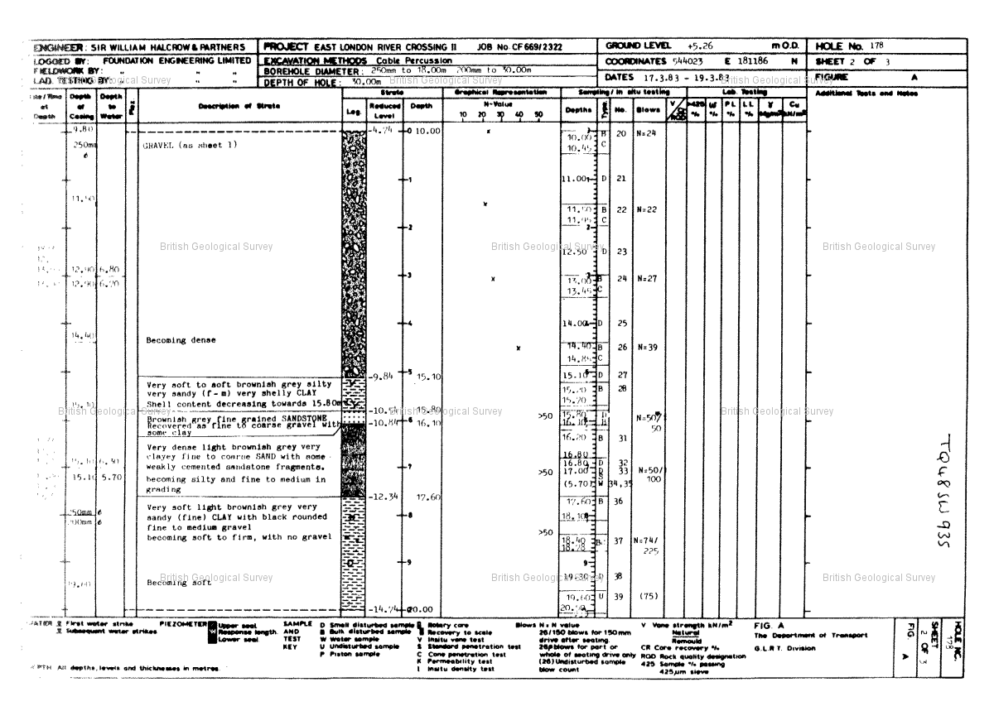

Reference : TQ48SW935

Name : E LONDON RVR CROSSING BH178

Year : null

Eastings: 544023 Northings: 181186

Sheet 3 of 3

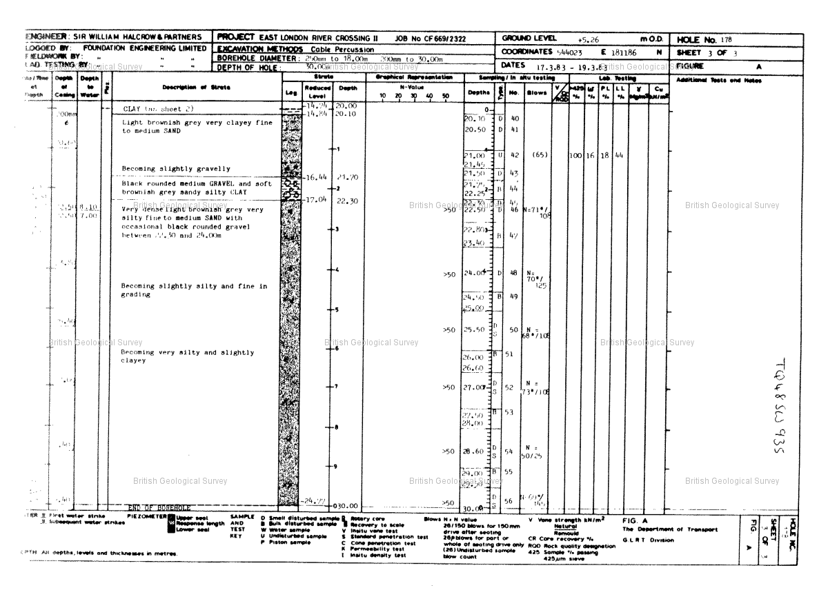

Reference : TQ48SW2536

Name : DLR BECKTON EXTENSION TP42

Year : 1987

Eastings: 544100 Northings: 181250

Sheet 1 of 8

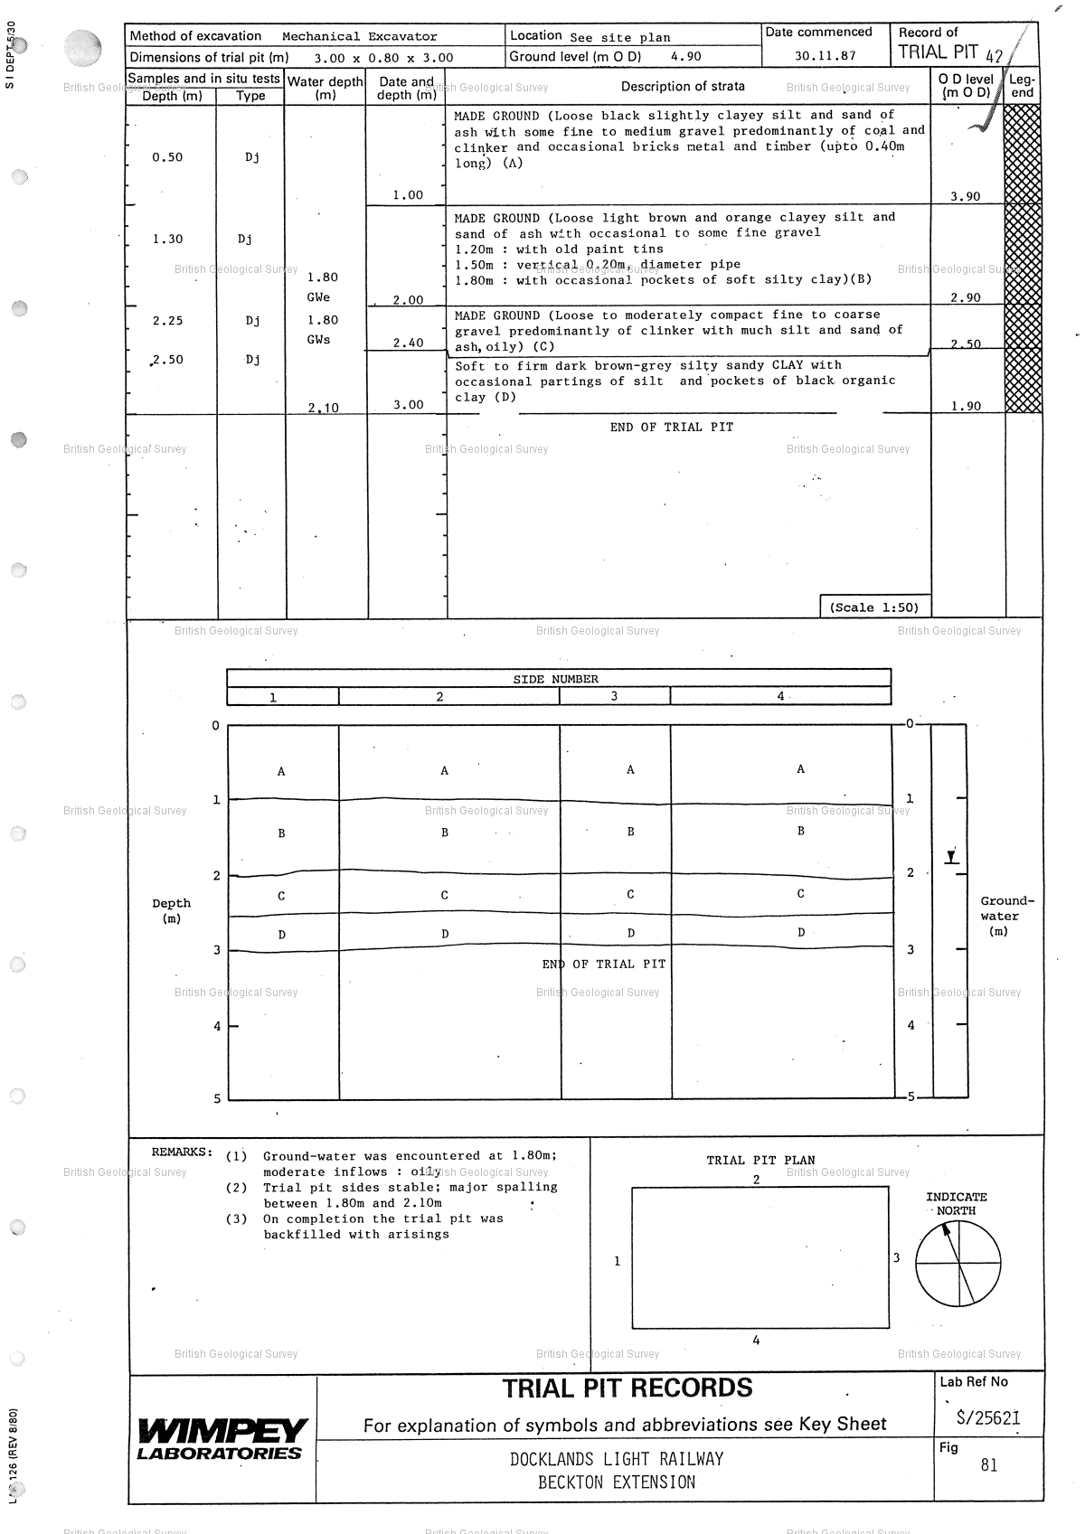

Reference : TQ48SW2536

Name : DLR BECKTON EXTENSION TP42

Year : 1987

Eastings: 544100 Northings: 181250

Sheet 2 of 8

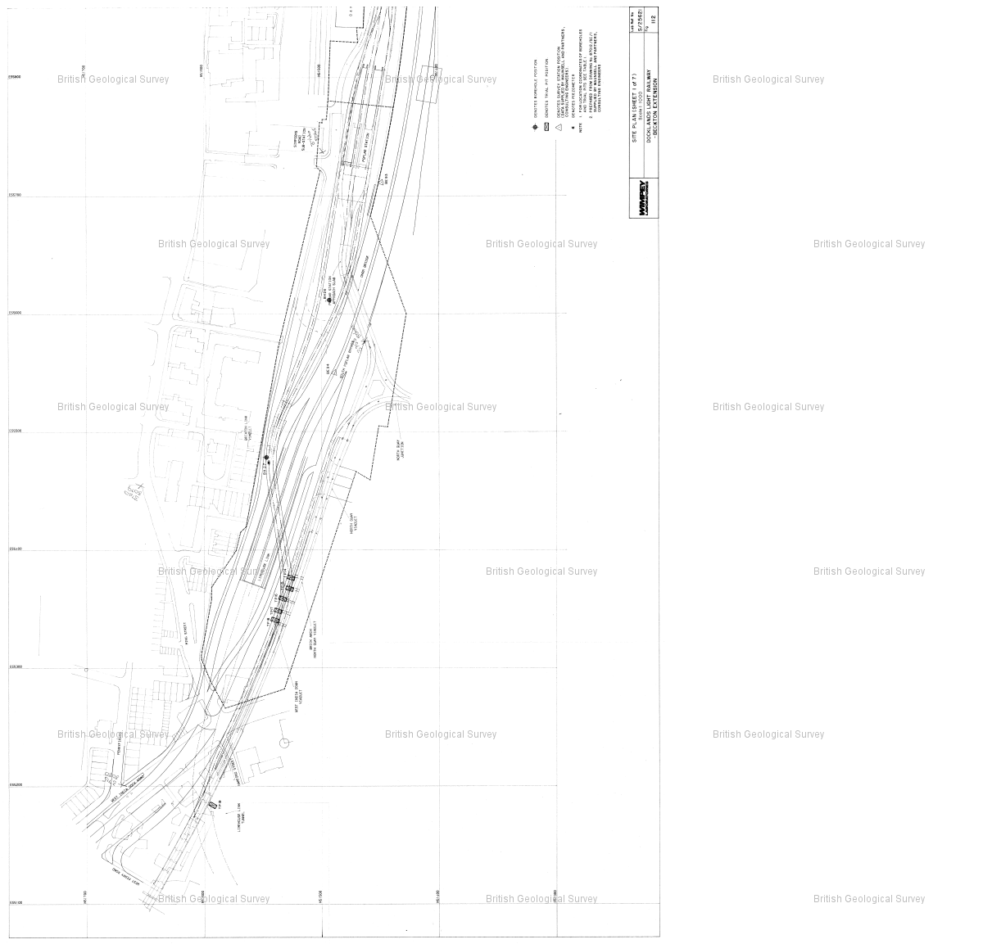

Reference : TQ48SW2536

Name : DLR BECKTON EXTENSION TP42

Year : 1987

Eastings: 544100 Northings: 181250

Sheet 3 of 8

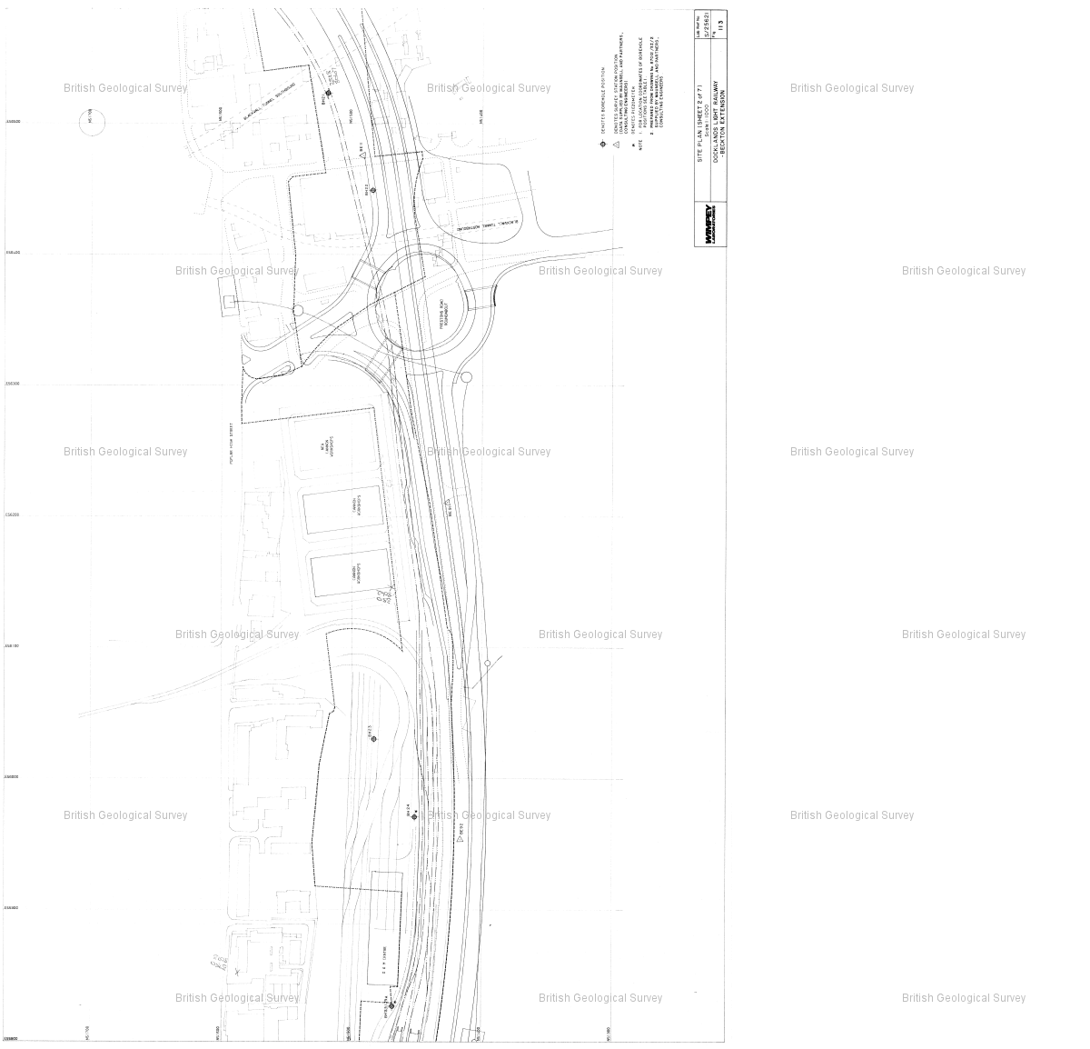

Reference : TQ48SW2536

Name : DLR BECKTON EXTENSION TP42

Year : 1987

Eastings: 544100 Northings: 181250

Sheet 4 of 8

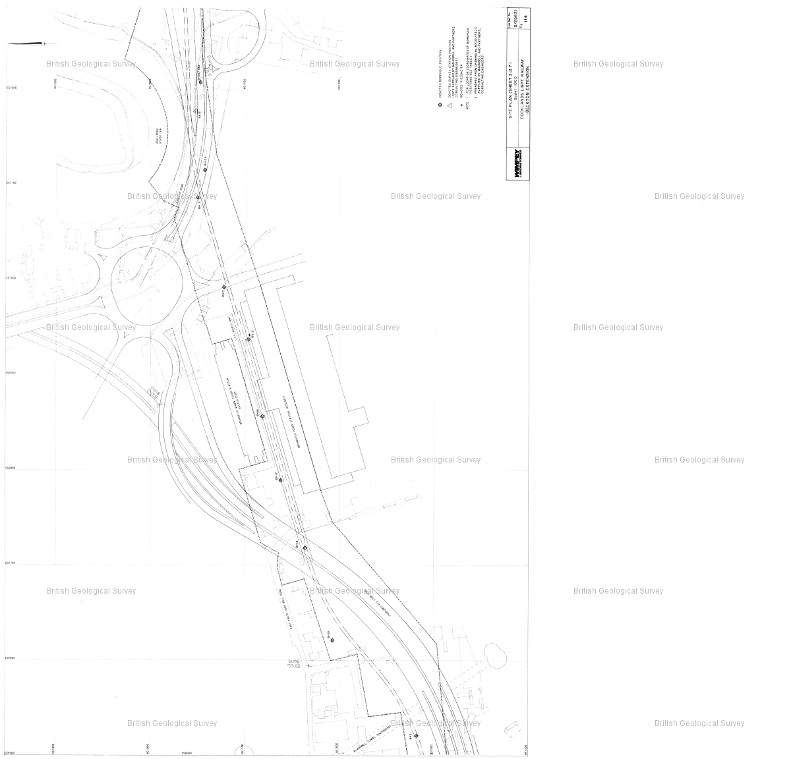

Reference : TQ48SW2536

Name : DLR BECKTON EXTENSION TP42

Year : 1987

Eastings: 544100 Northings: 181250

Sheet 5 of 8

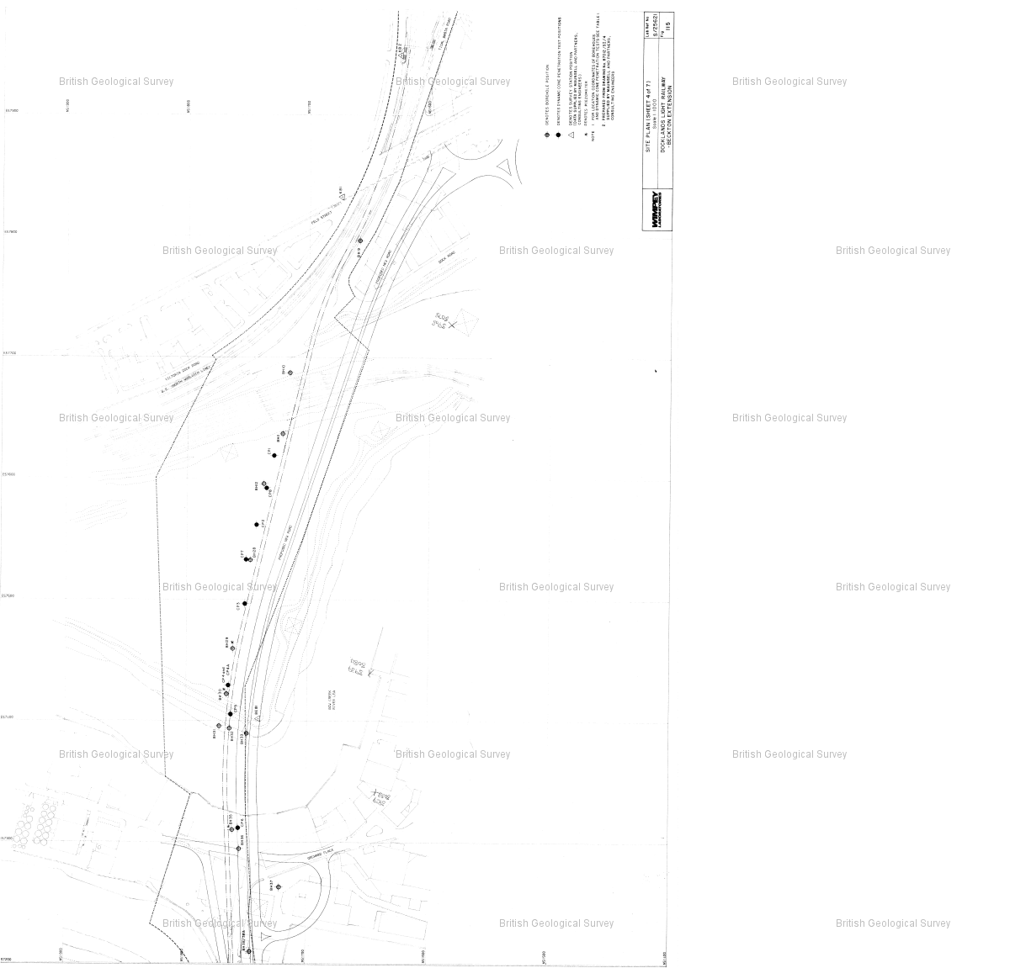

Reference : TQ48SW2536

Name : DLR BECKTON EXTENSION TP42

Year : 1987

Eastings: 544100 Northings: 181250

Sheet 6 of 8

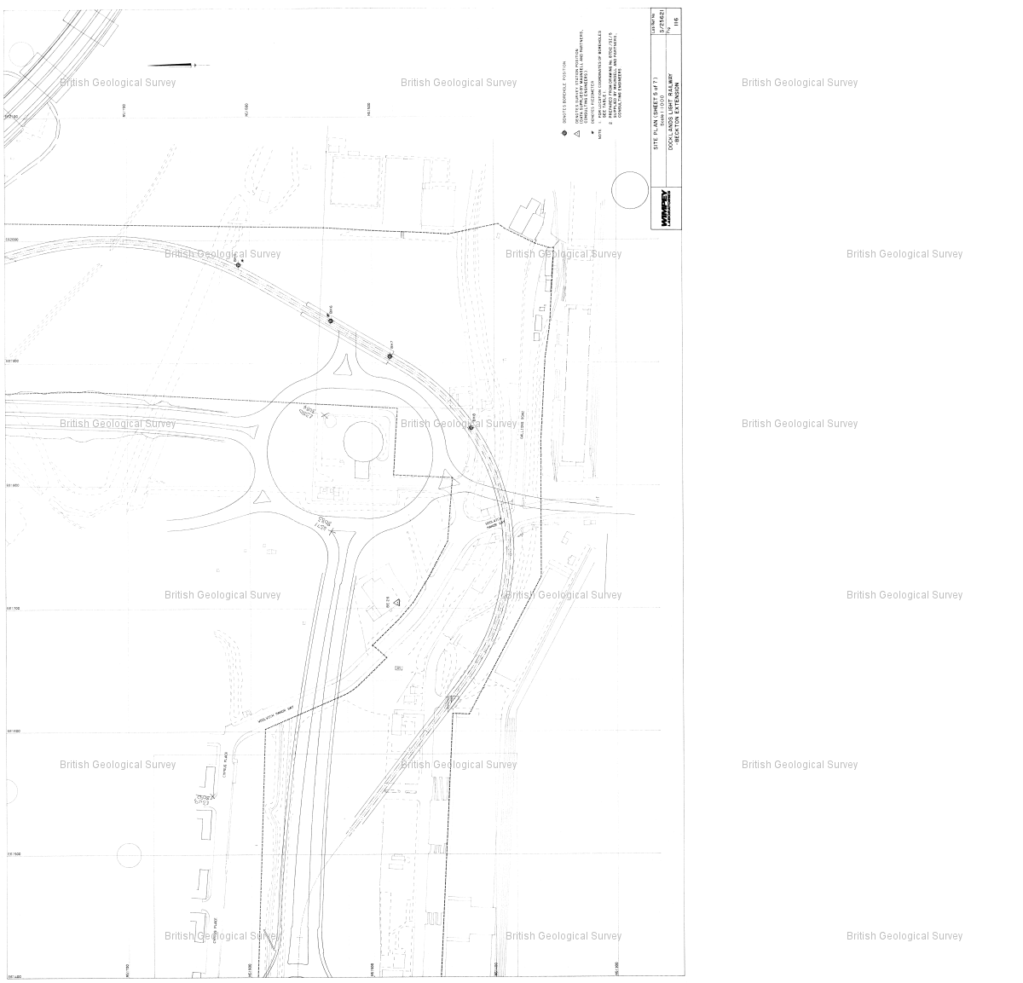

Reference : TQ48SW2536

Name : DLR BECKTON EXTENSION TP42

Year : 1987

Eastings: 544100 Northings: 181250

Sheet 7 of 8

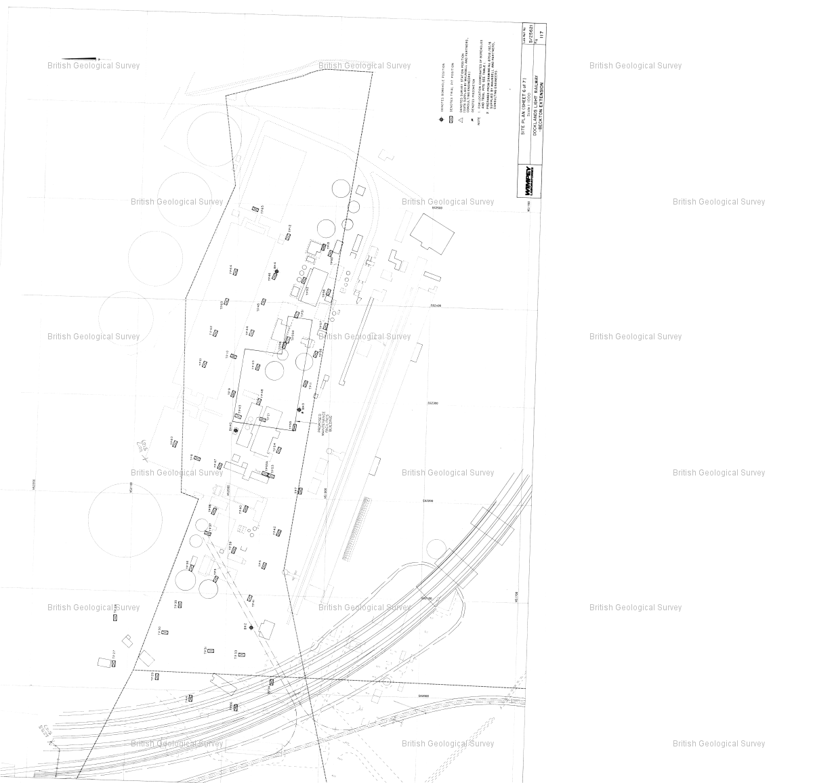

Reference : TQ48SW2536

Name : DLR BECKTON EXTENSION TP42

Year : 1987

Eastings: 544100 Northings: 181250

Sheet 8 of 8

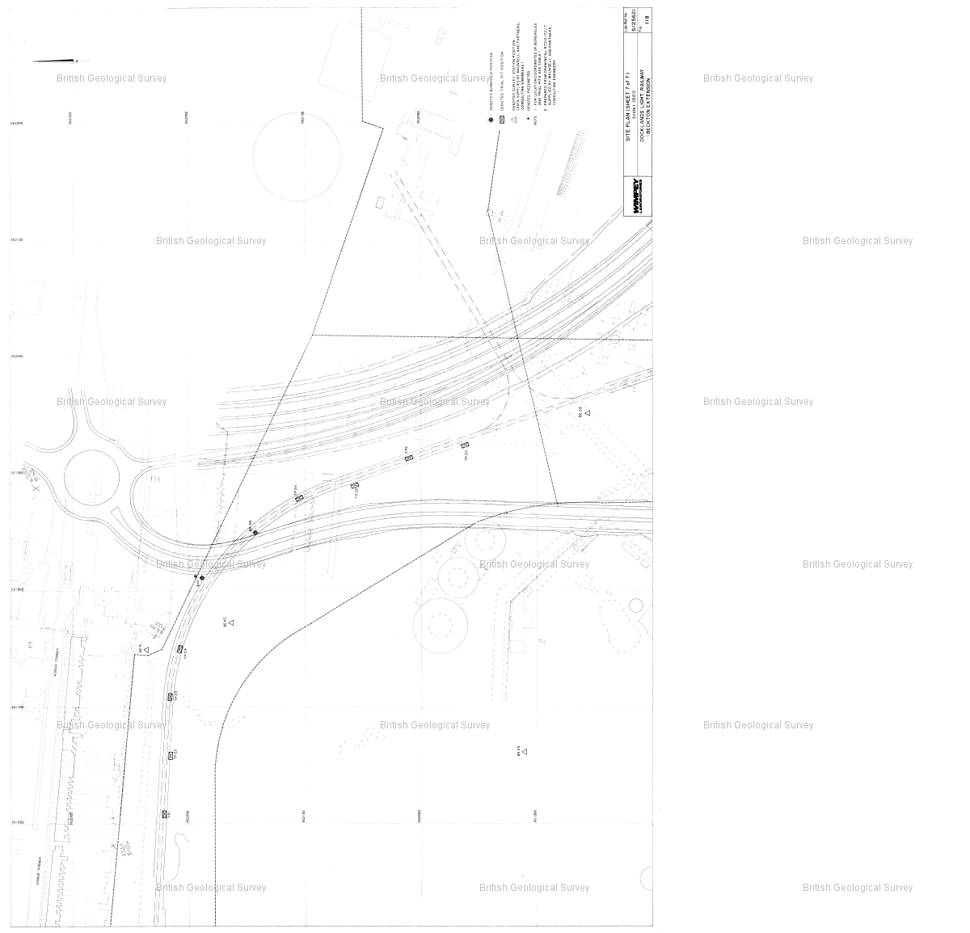

Reference : TQ48SW2508

Name : DLR BECKTON EXTENSION TP7

Year : 1987

Eastings: 544150 Northings: 181230

Sheet 1 of 8

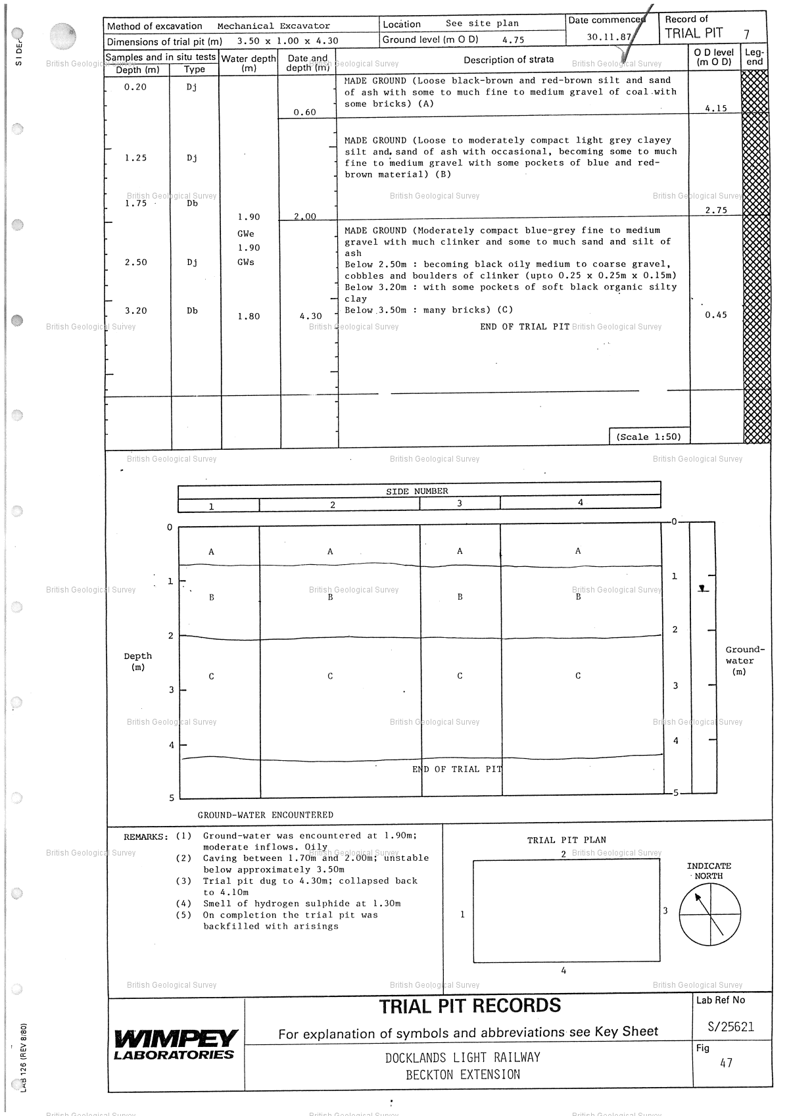

Reference : TQ48SW2508

Name : DLR BECKTON EXTENSION TP7

Year : 1987

Eastings: 544150 Northings: 181230

Sheet 2 of 8

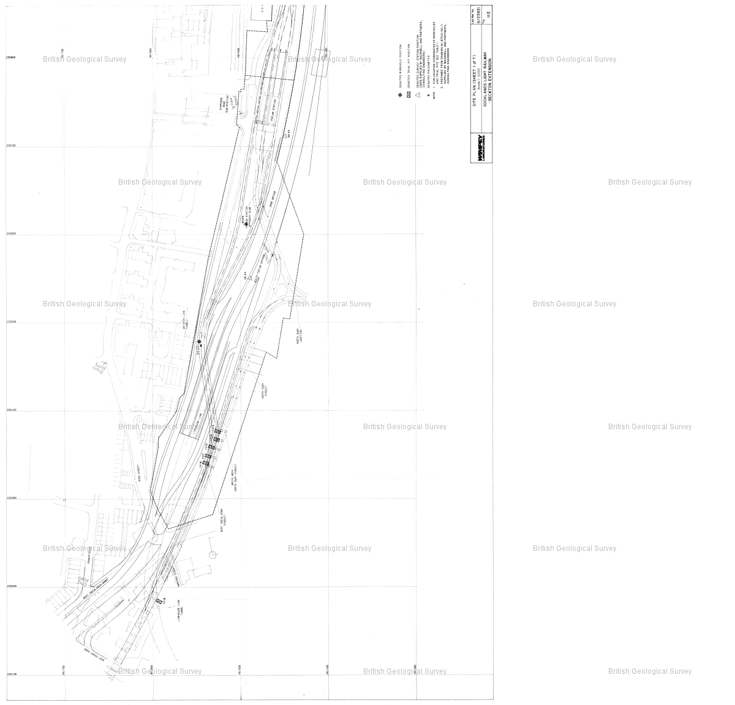

Reference : TQ48SW2508

Name : DLR BECKTON EXTENSION TP7

Year : 1987

Eastings: 544150 Northings: 181230

Sheet 3 of 8

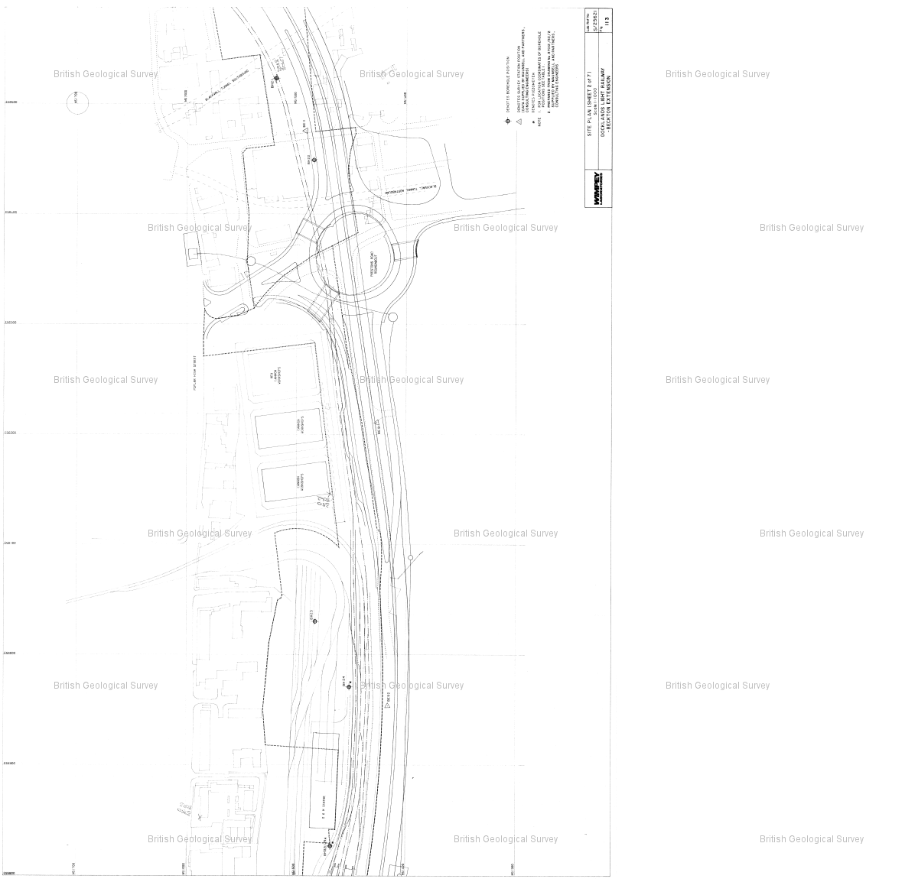

Reference : TQ48SW2508

Name : DLR BECKTON EXTENSION TP7

Year : 1987

Eastings: 544150 Northings: 181230

Sheet 4 of 8

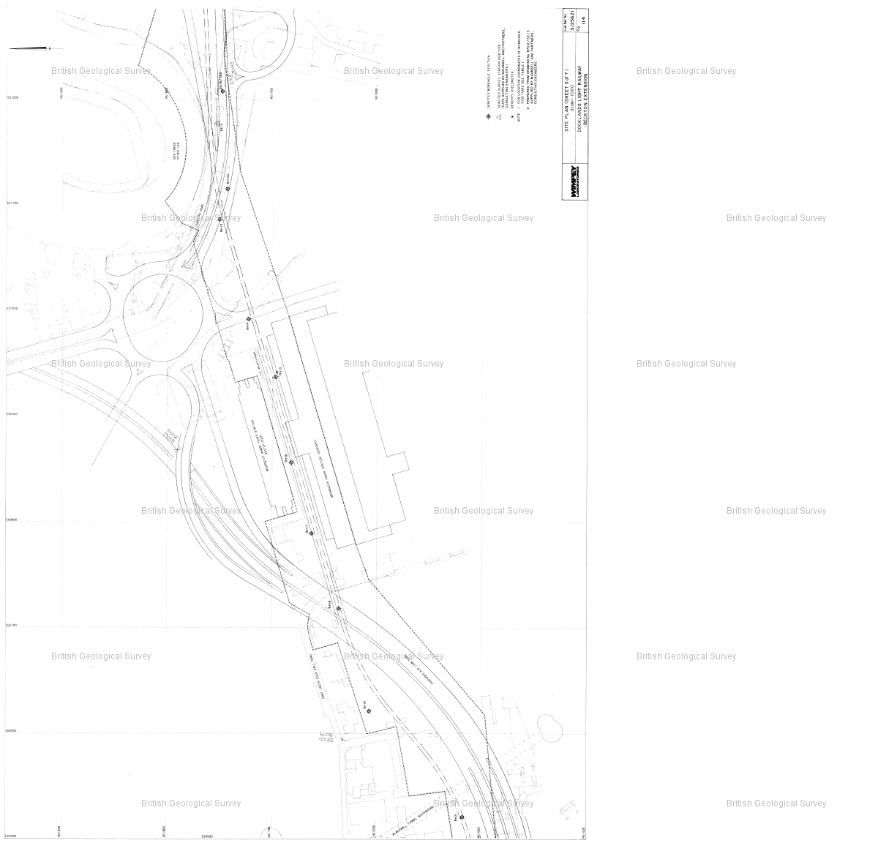

Reference : TQ48SW2508

Name : DLR BECKTON EXTENSION TP7

Year : 1987

Eastings: 544150 Northings: 181230

Sheet 5 of 8

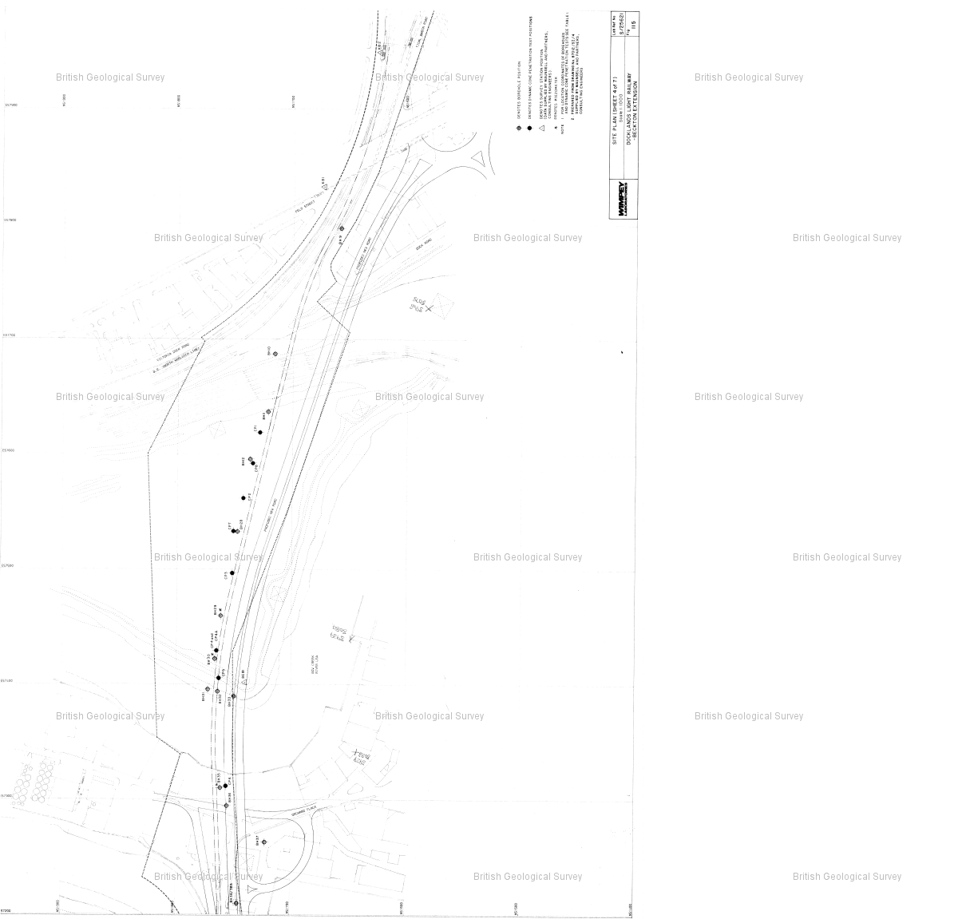

Reference : TQ48SW2508

Name : DLR BECKTON EXTENSION TP7

Year : 1987

Eastings: 544150 Northings: 181230

Sheet 6 of 8

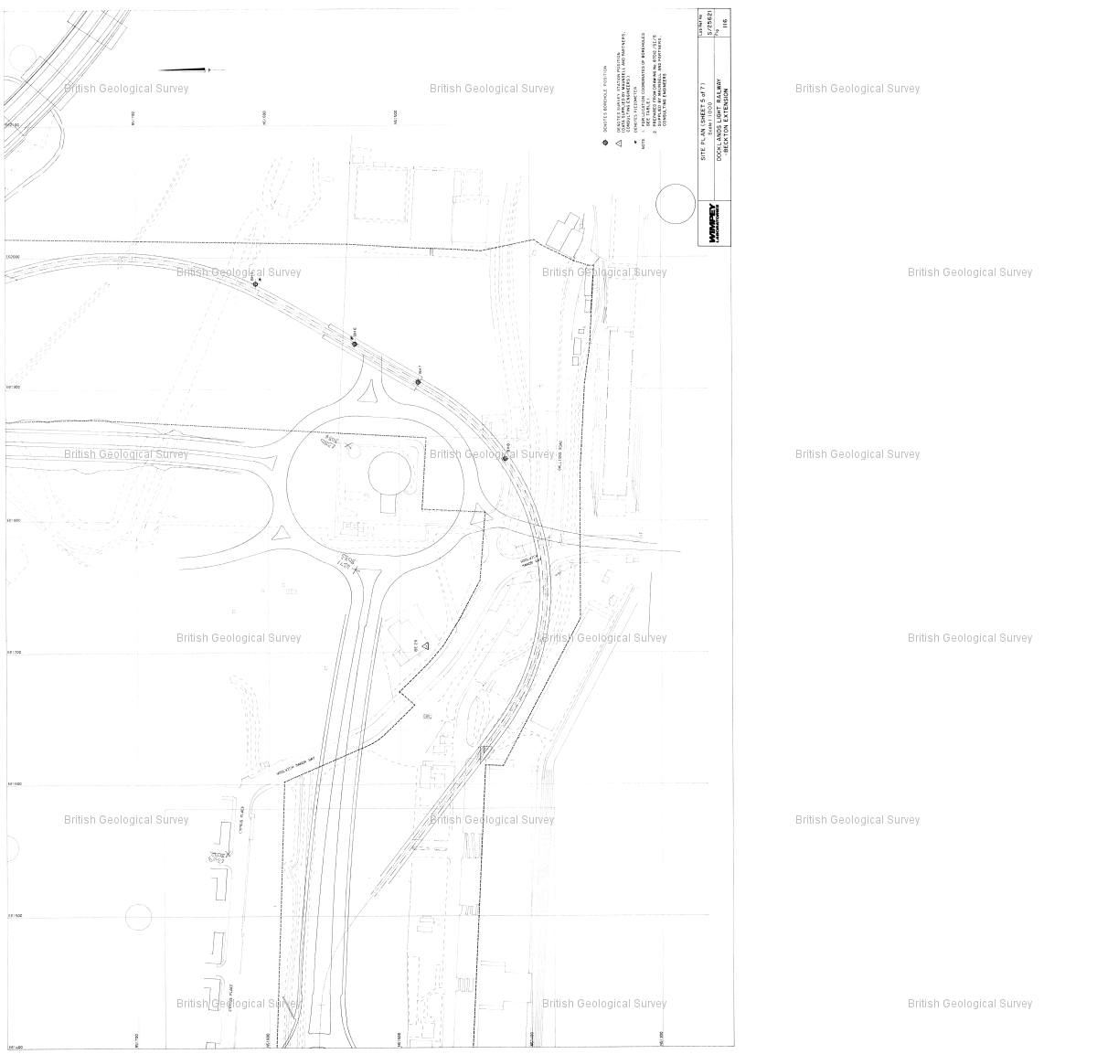

Reference : TQ48SW2508

Name : DLR BECKTON EXTENSION TP7

Year : 1987

Eastings: 544150 Northings: 181230

Sheet 7 of 8

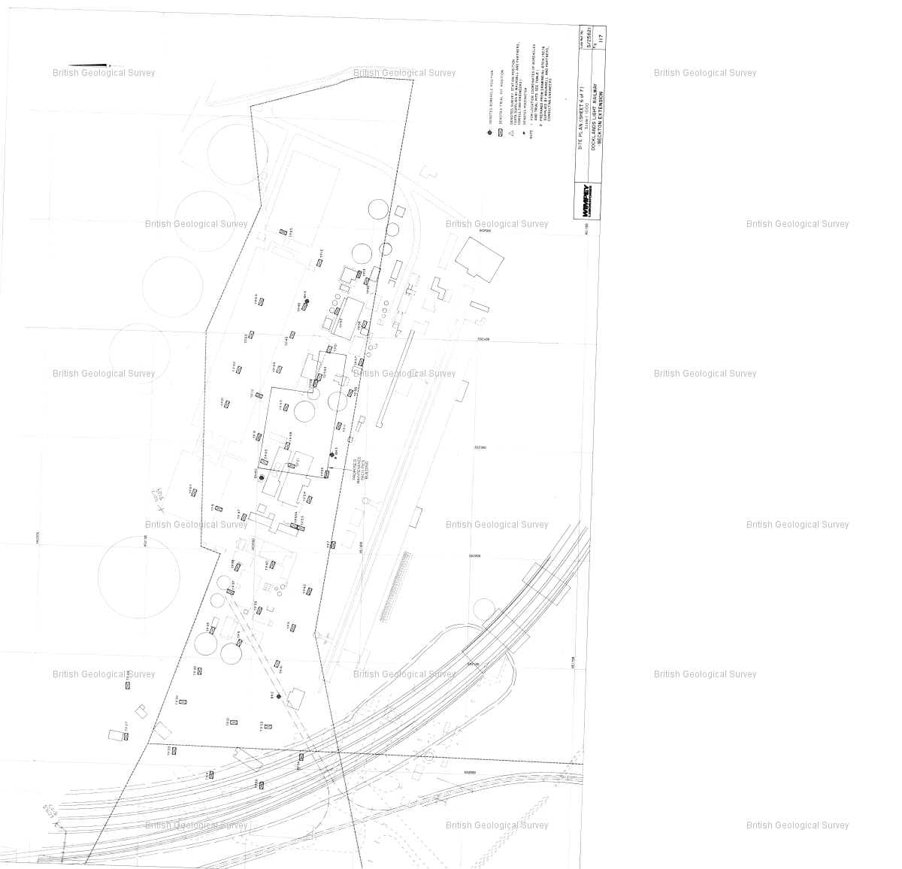

Reference : TQ48SW2508

Name : DLR BECKTON EXTENSION TP7

Year : 1987

Eastings: 544150 Northings: 181230

Sheet 8 of 8

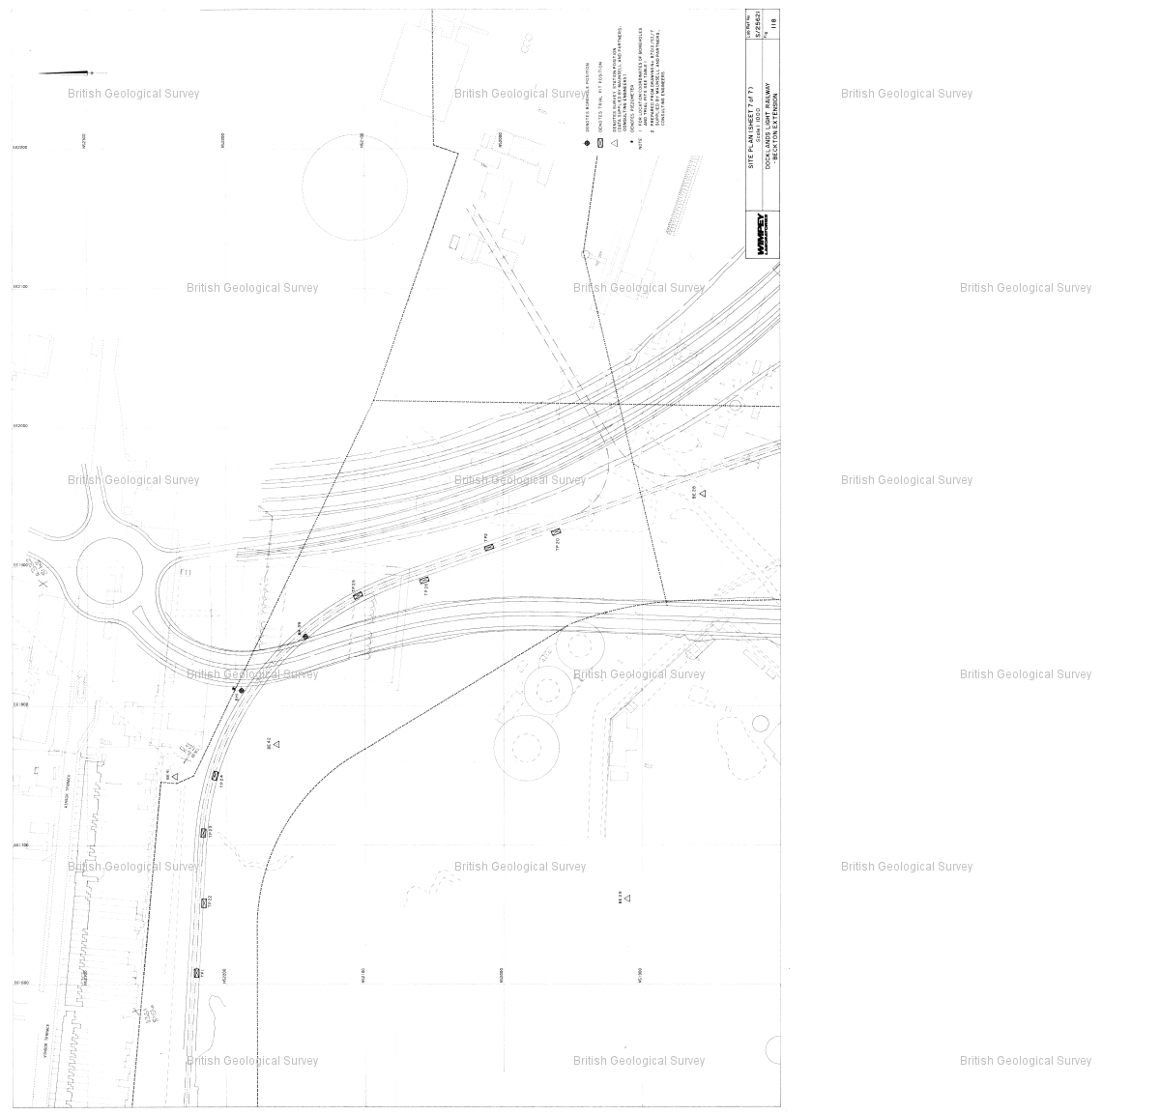

Reference : TQ48SW936

Name : E LONDON RVR CROSSING BH179

Year : null

Eastings: 543976 Northings: 181194

Sheet 1 of 3

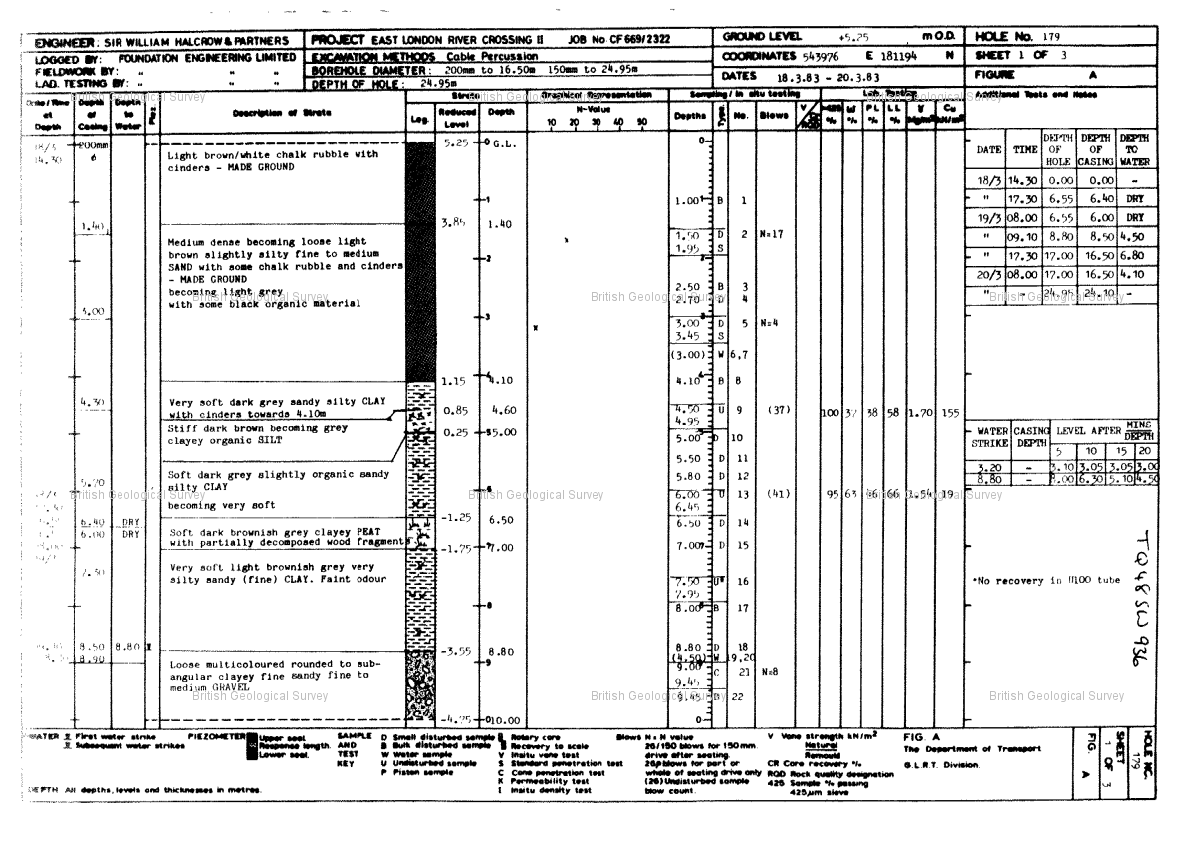

Reference : TQ48SW936

Name : E LONDON RVR CROSSING BH179

Year : null

Eastings: 543976 Northings: 181194

Sheet 2 of 3

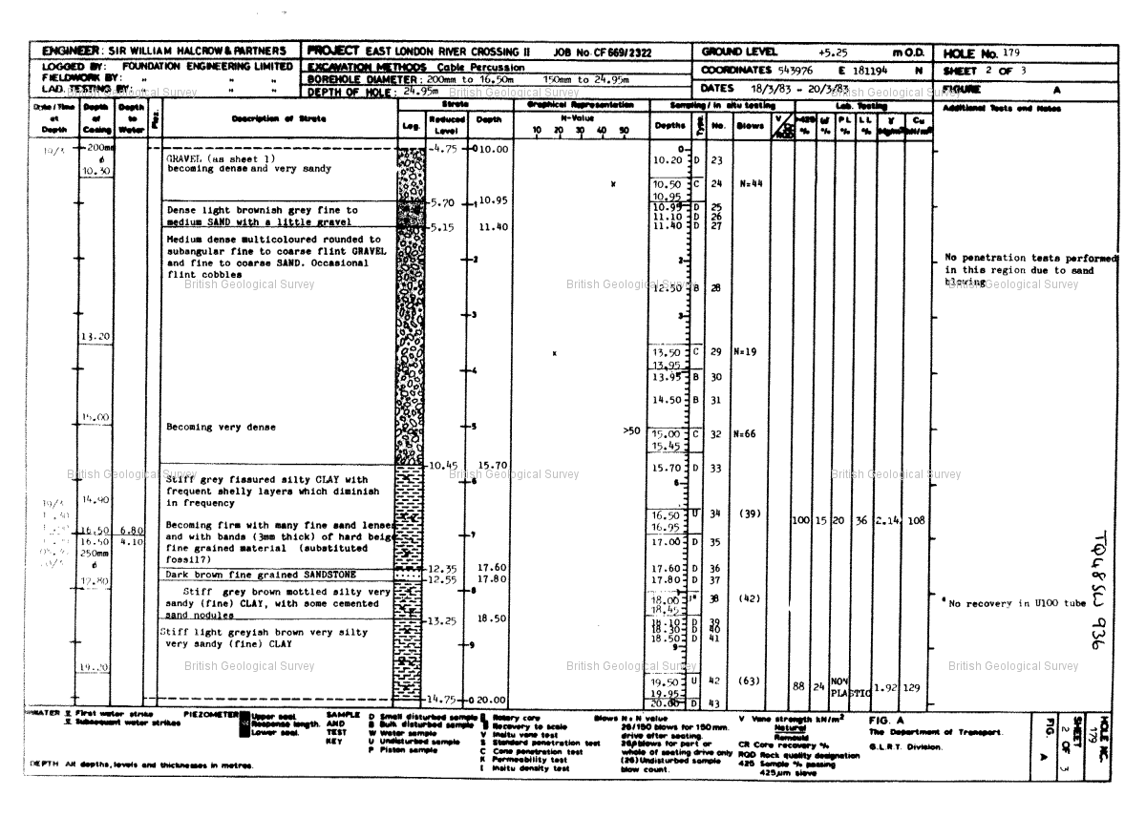

Reference : TQ48SW936

Name : E LONDON RVR CROSSING BH179

Year : null

Eastings: 543976 Northings: 181194

Sheet 3 of 3

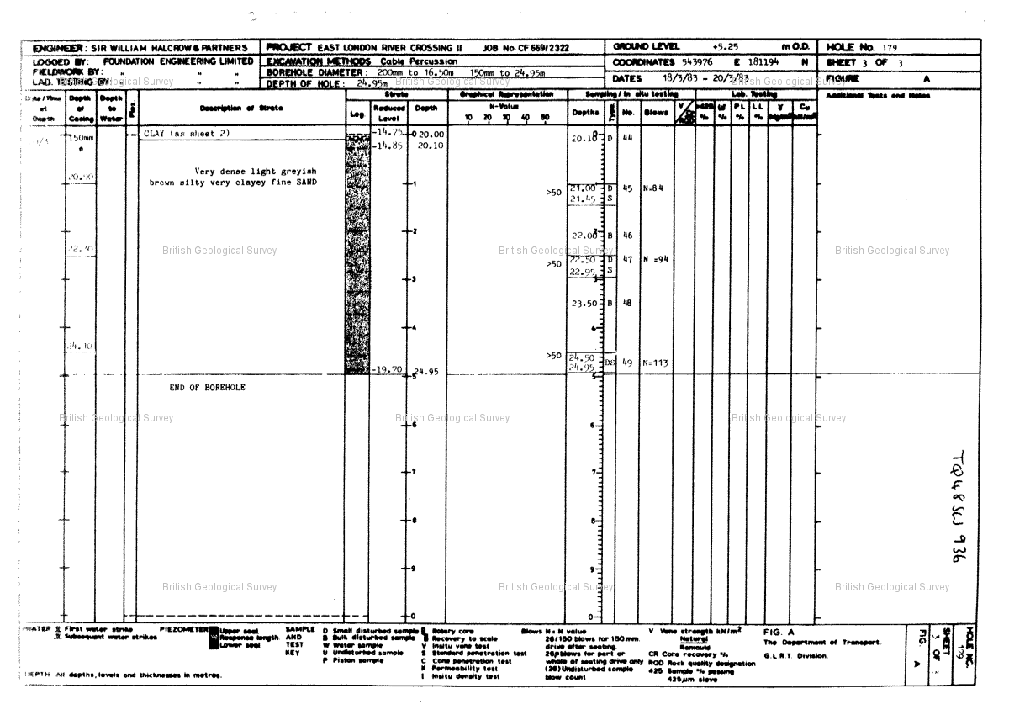

Reference : TQ48SW2528

Name : DLR BECKTON EXTENSION TP34

Year : 1987

Eastings: 543950 Northings: 181250

Sheet 1 of 8

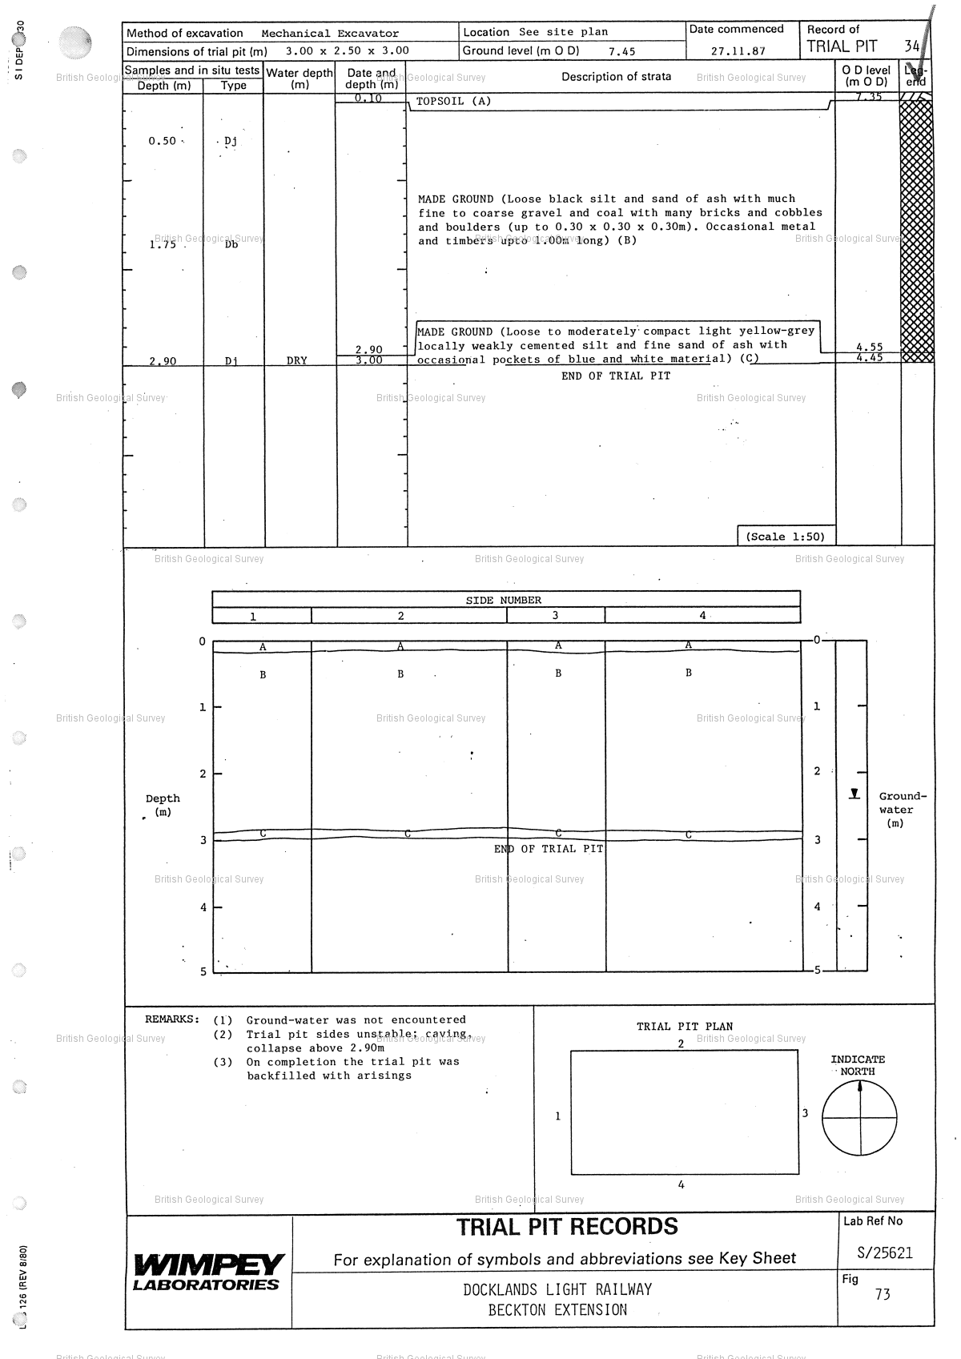

Reference : TQ48SW2528

Name : DLR BECKTON EXTENSION TP34

Year : 1987

Eastings: 543950 Northings: 181250

Sheet 2 of 8

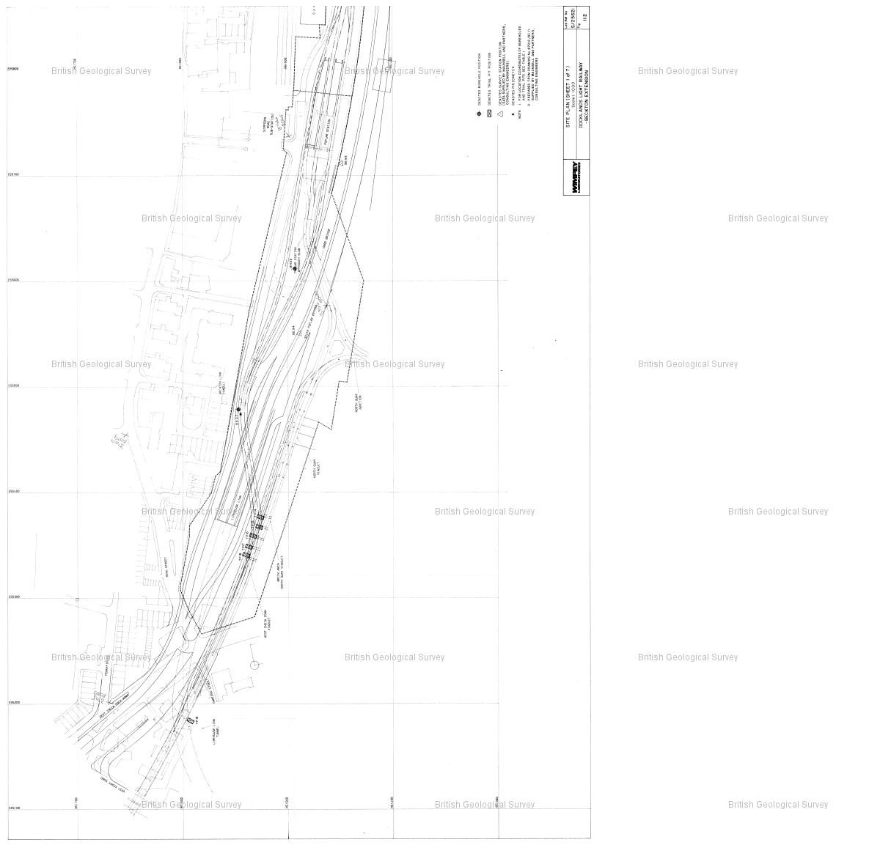

Reference : TQ48SW2528

Name : DLR BECKTON EXTENSION TP34

Year : 1987

Eastings: 543950 Northings: 181250

Sheet 3 of 8

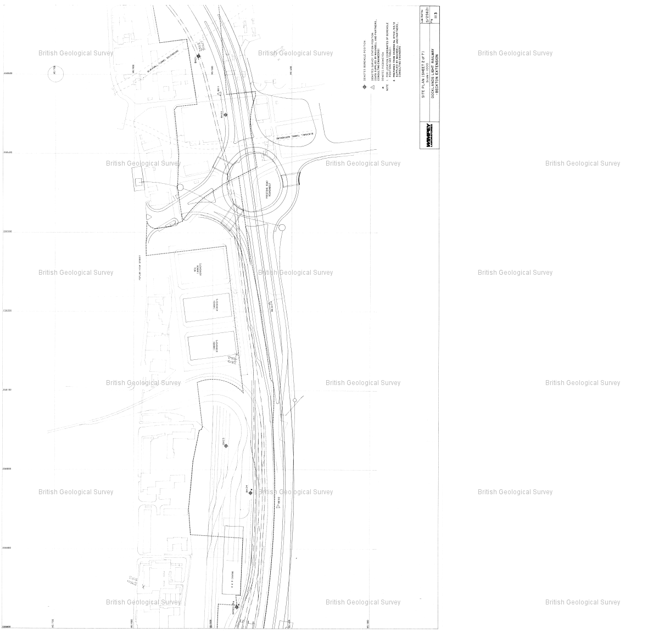

Reference : TQ48SW2528

Name : DLR BECKTON EXTENSION TP34

Year : 1987

Eastings: 543950 Northings: 181250

Sheet 4 of 8

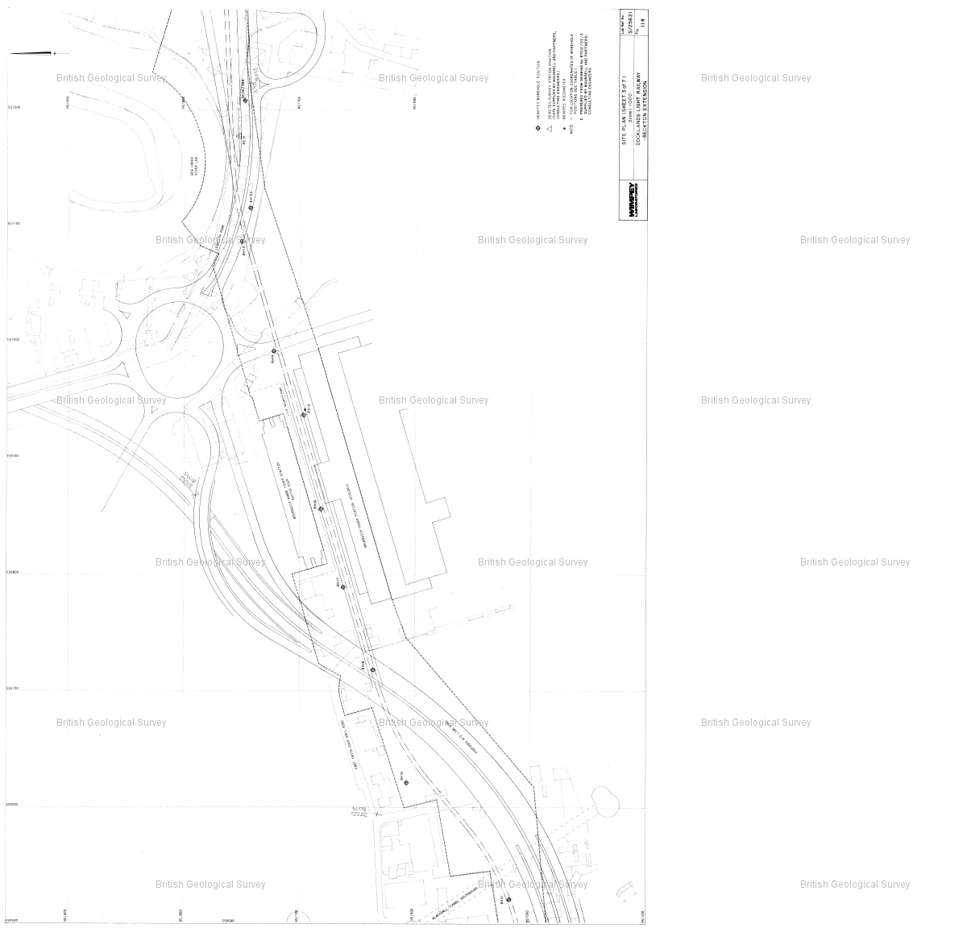

Reference : TQ48SW2528

Name : DLR BECKTON EXTENSION TP34

Year : 1987

Eastings: 543950 Northings: 181250

Sheet 5 of 8

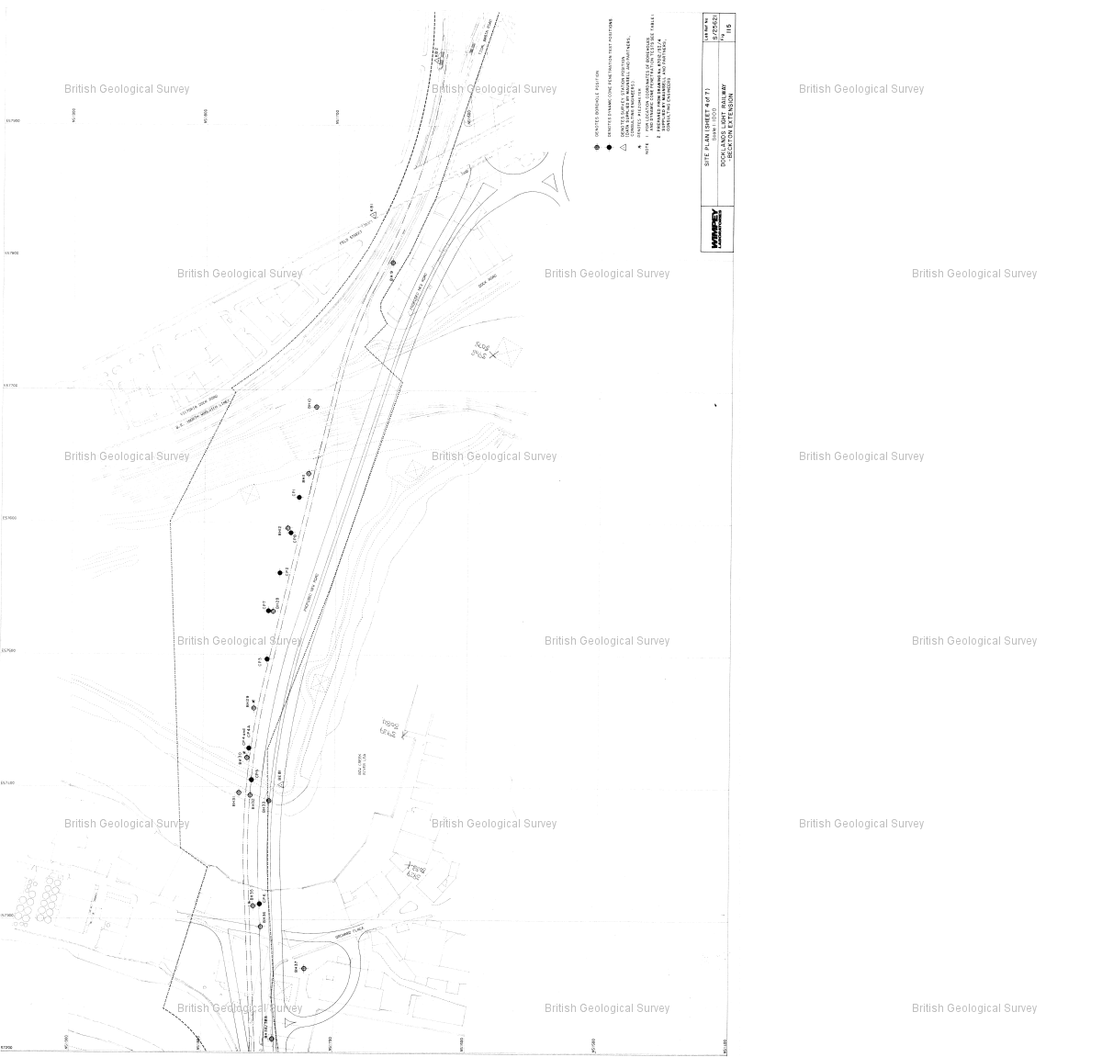

Reference : TQ48SW2528

Name : DLR BECKTON EXTENSION TP34

Year : 1987

Eastings: 543950 Northings: 181250

Sheet 6 of 8

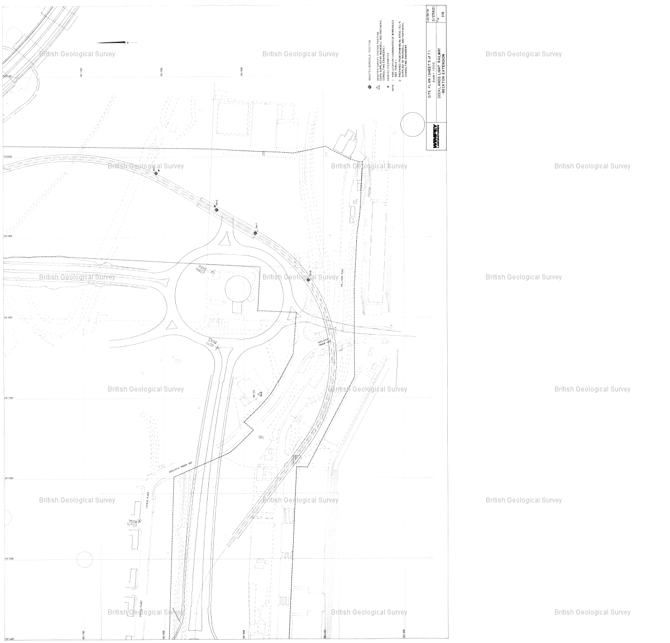

Reference : TQ48SW2528

Name : DLR BECKTON EXTENSION TP34

Year : 1987

Eastings: 543950 Northings: 181250

Sheet 7 of 8

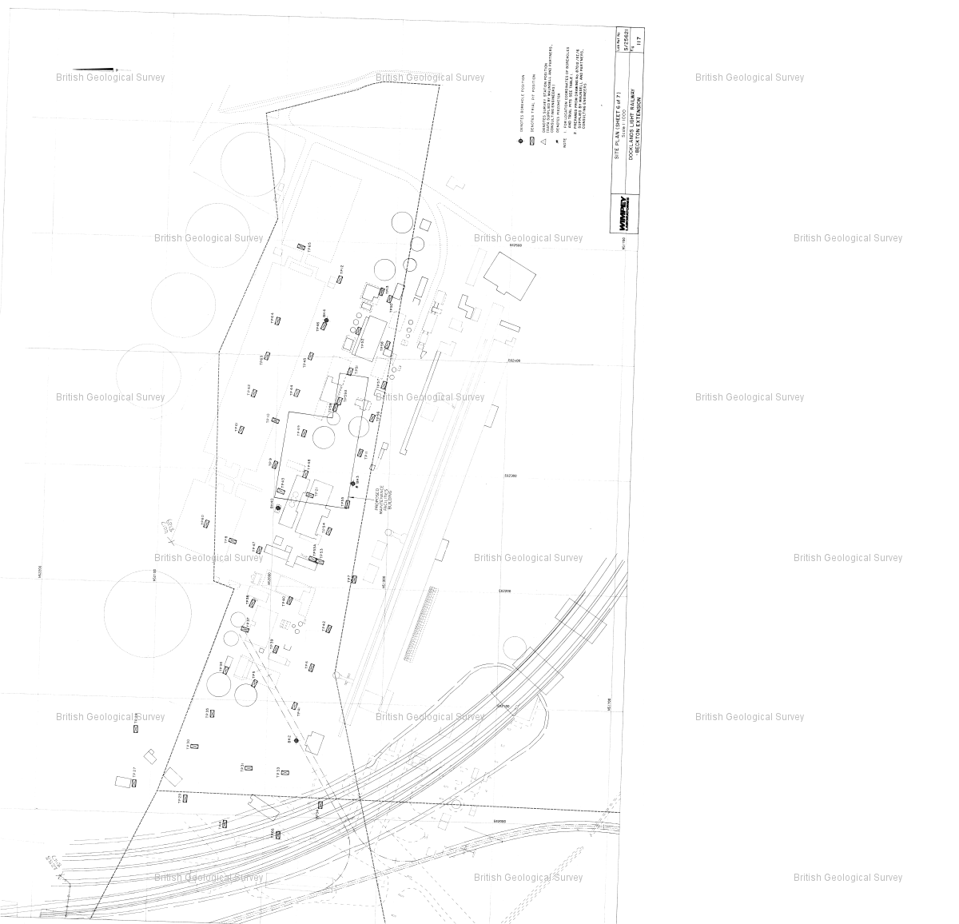

Reference : TQ48SW2528

Name : DLR BECKTON EXTENSION TP34

Year : 1987

Eastings: 543950 Northings: 181250

Sheet 8 of 8

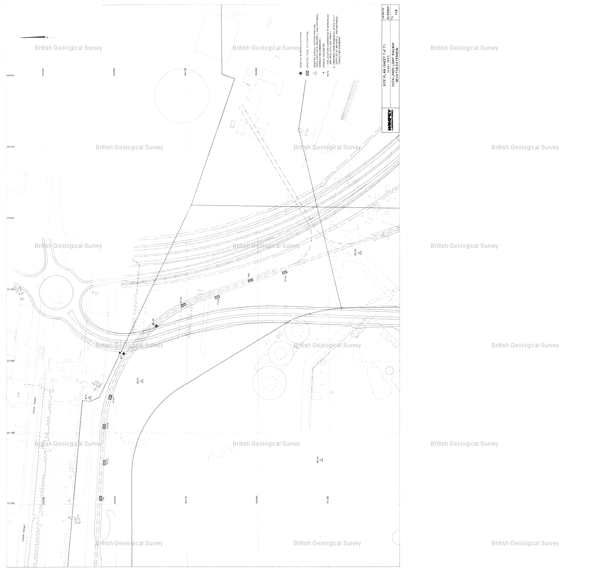

Reference : TQ48SW937

Name : E LONDON RVR CROSSING BH180

Year : null

Eastings: 543990 Northings: 181250

Sheet 1 of 5

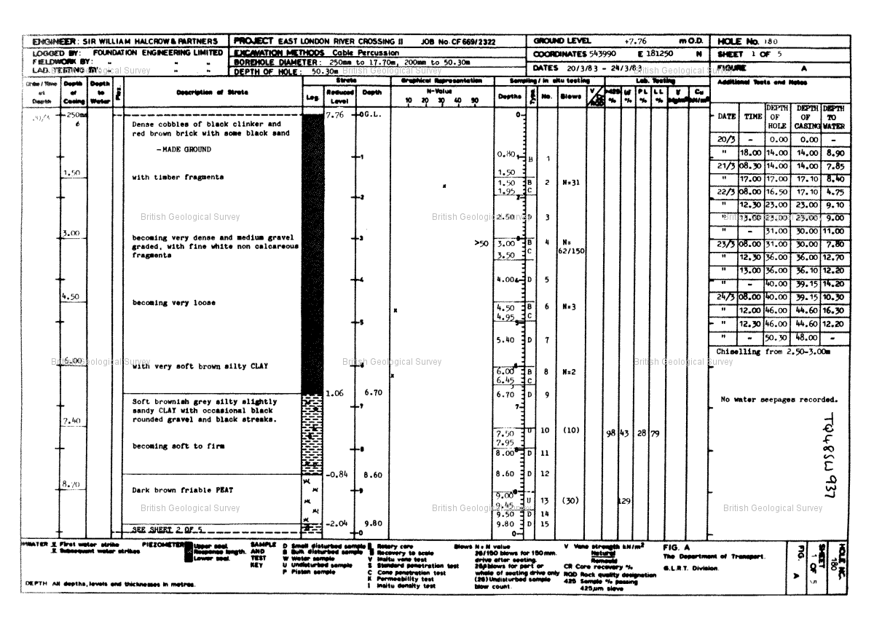

Reference : TQ48SW937

Name : E LONDON RVR CROSSING BH180

Year : null

Eastings: 543990 Northings: 181250

Sheet 2 of 5

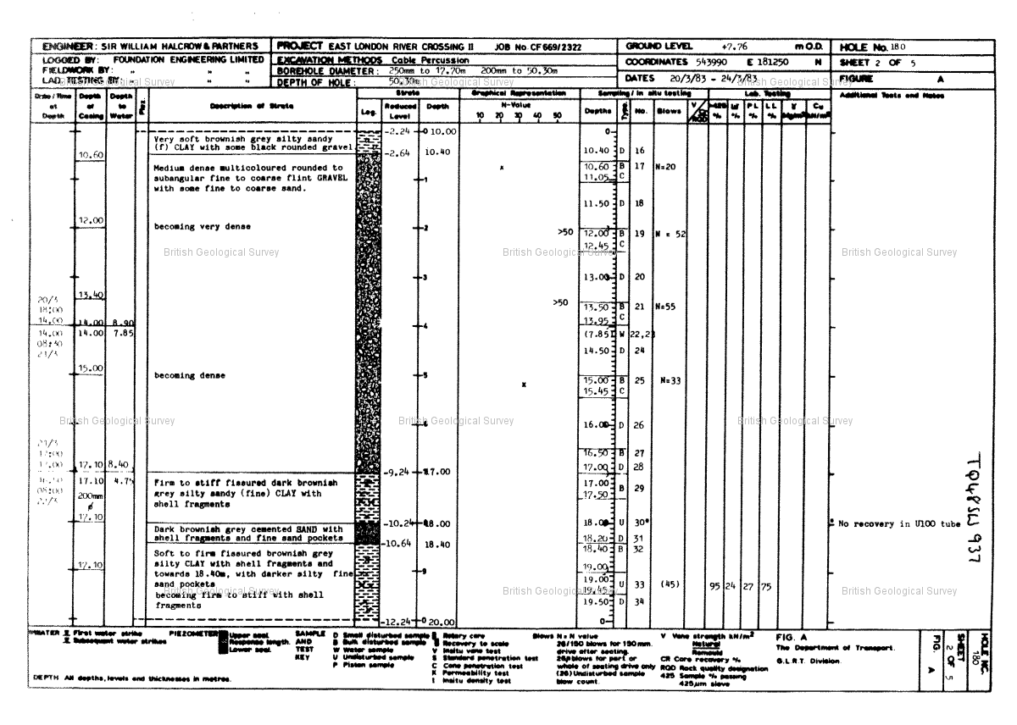

Reference : TQ48SW937

Name : E LONDON RVR CROSSING BH180

Year : null

Eastings: 543990 Northings: 181250

Sheet 3 of 5

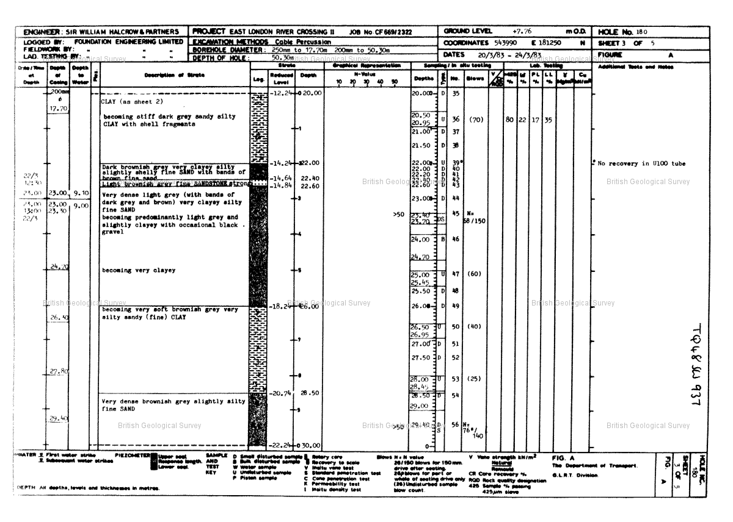

Reference : TQ48SW937

Name : E LONDON RVR CROSSING BH180

Year : null

Eastings: 543990 Northings: 181250

Sheet 4 of 5

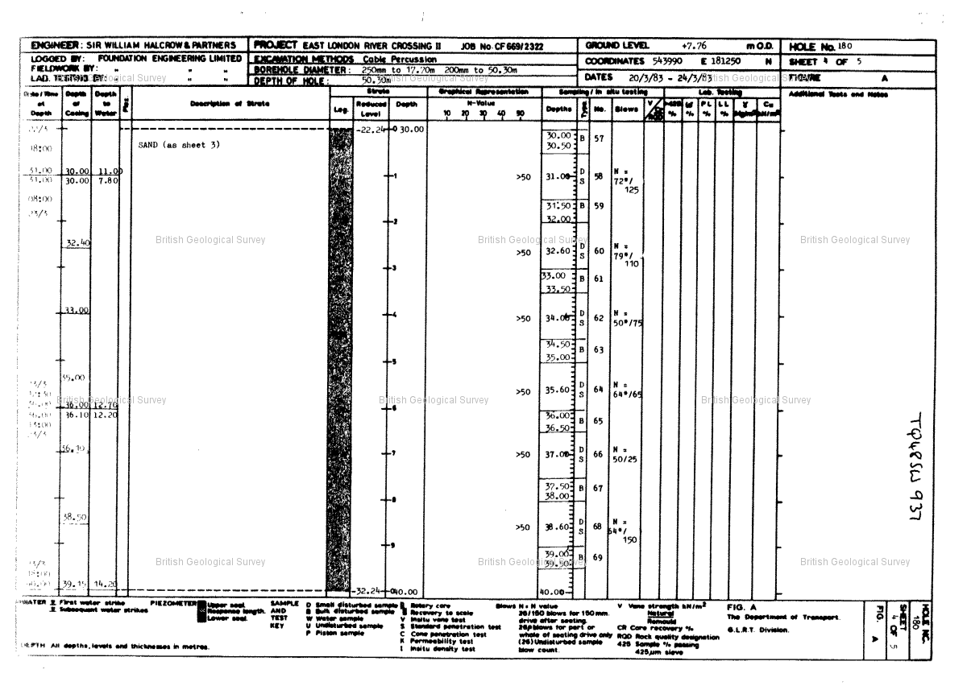

Reference : TQ48SW937

Name : E LONDON RVR CROSSING BH180

Year : null

Eastings: 543990 Northings: 181250

Sheet 5 of 5

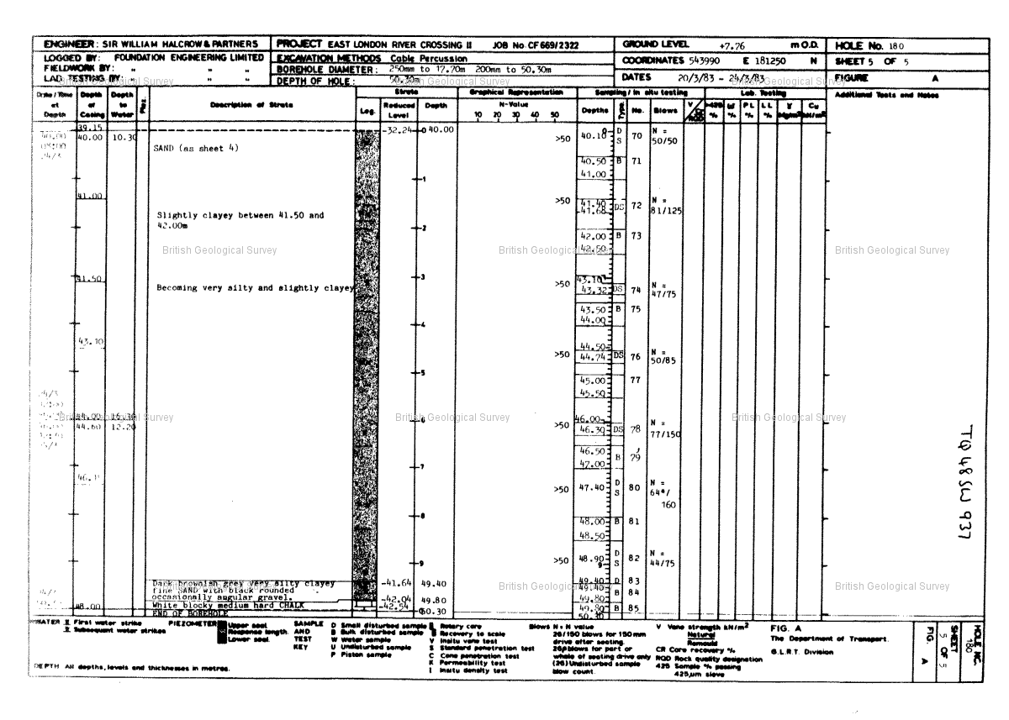

Reference : TQ48SW938

Name : E LONDON RVR CROSSING BH181

Year : null

Eastings: 543947 Northings: 181253

Sheet 1 of 2

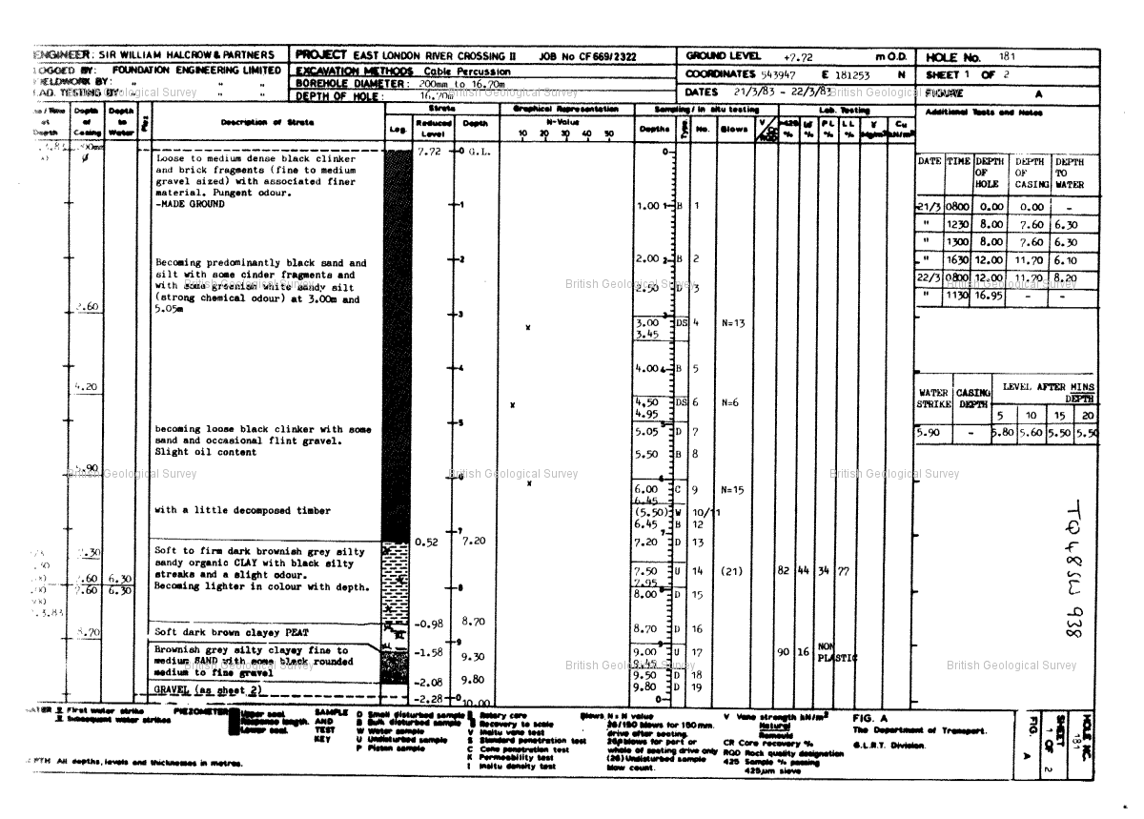

Reference : TQ48SW938

Name : E LONDON RVR CROSSING BH181

Year : null

Eastings: 543947 Northings: 181253

Sheet 2 of 2

